**Reinforcement Learning (RL)**

**Introduction to reinforcement learning**

* Reinforcement learning (RL) assumes Partially Observable (PO) Markov Decision Processes as a model

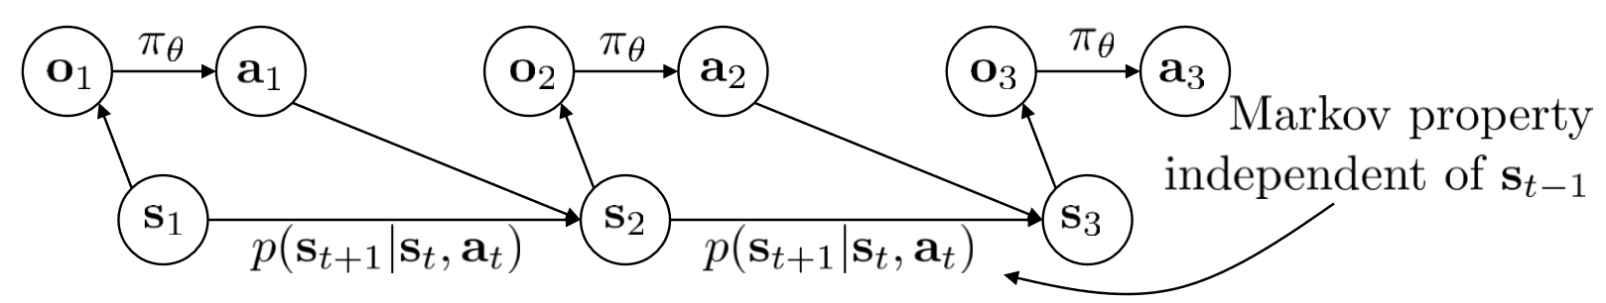

* Markov Decision Processes (MDPs) are basically Markov chains with actions; the future state $s_{t}$ is a function of both the current state $s_{t}$ and the action $a_{t}$ taken in response
* Mathematical framework for modelling decision making in situations in which the outcome is only partly under the control of the decision maker
* When the decision maker decides for $a_{t}$ under state $s_{t}$ it receives a reward $r(s_{t},a_{t})$– this is called the reward function
* The core problem in MDPs is to find a policy $a_{t}=π(s_{t})$ that the decision maker can follow
* POMDPs are hidden Markov models with actions; the decision maker does not observe the state of the world directly, but only some observables $o_{t}$
* As the observables are a random function of the state, with emission probability $p(o_{t}|s_{t})$, the decision maker is left in a state of uncertainty
* The Reinforcement Learning (RL) problem reads as follows

$θ^{*}=\arg{\max_{θ}{E_{τ\sim p_{θ}(τ)}\left[\sum_{t}{r(s_{t},a_{t})}\right]}}$ (1)

Subject to

$$p_{θ}\left(τ\right)=p_{θ}\left(s_{1},a_{1},…,s_{T},a_{T}\right)=p(s_{1})\prod_{t=1}^{T}{π_{θ}(a_{t}|s_{t})p(s_{t+1}|s_{t},a_{t})}$$ (2)

* [The assumption here is that the way the world works is a given, $p(s_{t+1}|s_{t},a_{t})$; what the decision maker can control is the policy $π_{θ}(a_{t}|s_{t})$, which is why we optimise for $θ$]
* Such a model is in fact equivalent to a Markov chain in the pair $(s,a)$
* The objective function of the RL problem is in fact a function of the state-action marginal $p_{θ}\left(s_{t},a_{t}\right)$ [*this is a marginal with respect to $p_{θ}\left(τ\right)=p_{θ}\left(s_{1},a_{1},…,s_{T},a_{T}\right)$; we are also assuming that the probability of a pair $(s,a)$ to be generated in invariant over time*]
* in the finite horizon case this reads as
$$θ^{*}=\arg{\max_{θ}{\sum_{t=1}^{T}{E_{\left(s_{t},a_{t}\right)\sim p_{θ}\left(s_{t},a_{t}\right)}[r\left(s_{t},a_{t}\right)]}}}$$

* In the infinite horizon case (T = ∝), we seek $p_{θ}\left(s_{t},a_{t}\right)$ to converge to a stationary distribution (same before and after the transition)
  1. This translates into $p_{θ}\left(s_{t},a_{t}\right)$ to be an eigenvector of the transition tensor with eigenvalue 1
* In this case, our objective is to maximise the expected return, rather than the cumulative return over the horizon
$$θ^{*}=\arg{\max_{θ}{E_{\left(s,a\right)\sim p_{θ}\left(s,a\right)}[r\left(s,a\right)]}}$$

* General structure of an RL algorithm:

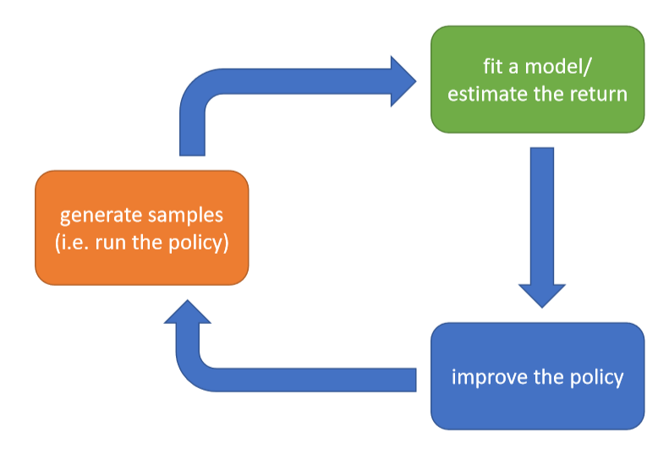

(1) Fit the model/estimate the return.

(2) Improve the policy.

(3) Generate samples by running the current policy.

* Example: reinforcement learning by backpropagation
  1. use a deterministic neural network as the model, $s_{t+1}=f_{ϕ}(s_{t},a_{t})$
  2. then back-propagate through *f* and *r* to train the policy $a_{t}=π_{θ}(s_{t})$

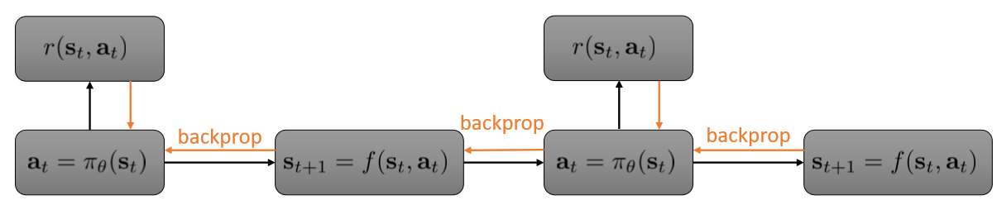

[*The mapping here is: given $s_{t}$ we apply the policy $π_{θ}$ to get $a_{t}$; we get a reward from $r(s_{t},a_{t})$* ; *then the world takes over and generates the new state $s_{t+1}$; and we cycle. This is a cascade of neural networks*]

* Deterministic models are not good enough -> to describe real world uncertainties we need stochasticity
* Q function: total reward after $(s_{t},a_{t})$: $E[R|s_{t},a_{t},π]$, where R is the total future reward after taking action $a_{t}$ in state $s_{t}$, or, over a finite horizon:

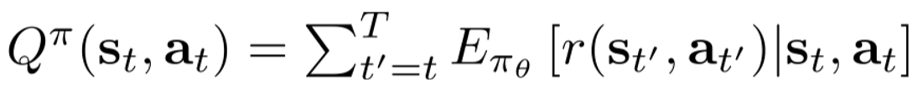

[*Again the assumption here is that the world is a given; hence the reward only depends on our choice of policy, with parameter $θ$* ]

* Value function: total reward after $s_{t}$ or $E[R|s_{t},π]$ (equivalently, the Q function averaged over $a_{t}$)
$$V^{π}\left(s_{t}\right)=\sum_{t^{'}=1}^{T}{E_{π_{θ}}[r(s_{t^{'}},a_{t^{'}})|s_{t}]}=E_{a_{t}\sim π(a_{t},s_{t})}[Q^{π}\left(s_{t},a_{t}\right)]$$

* The reinforcement learning objective (1) can be expressed in terms of the value function as follows:
$$J=E_{s_{1}\sim p(s_{1})}[V^{π}\left(s_{1}\right)]$$

* Two very important ideas in reinforcement learning:
  1. If we have a policy $π$, and we know $Q$, we can improve $π$ by setting

$π^{'}\left(a^{*} | s\right)=1$ if $a^{*}=\arg{\max_{a}{Q^{π}\left(s,a\right)}}$

Such a policy is at least as good as $π$, no matter what $π$ is

1. If $Q^{π}\left(s,a\right)>V^{π}\left(s\right)$ then $a$ is better than average as an action (since $V^{π}$ is the expectation of $Q^{π}$ over $a$); we can then change the policy $π$ by increasing the probability of $a$

[*Bottom line: knowing the Q-function or the V-function provides useful information about how to update the policy: see actor-critic approaches*]

* There are various types of reinforcement learning algorithms:
  + Policy gradients: explicitly *differentiate the expected return*, as in (1)
    - Evaluate the expected return;
    - Update policy parameters $θ$ through the gradient.
  + Actor-critic: estimate value- or Q-function of the *current* policy (critic), and use them to improve policy (actor)
    - (really a spin-off of policy gradient, see title of the original 1999 paper)
  + Value-based: estimate value- or Q-function of the *optimal* policy, then set:
 $$π\left(s\right)=\arg{\max_{a}{Q(s,a)}}$$

 + Model-based: *estimate the transition model*, and then either:
    - Just use the model to plan (optimize control, i.e., series of actions, without using a policy).
    - Back-propagate gradients into the policy (see previous example on RL by backpropagation in the deterministic case).
    - Use the model to learn a value function (and then we are back to actor-critic of value-based RL).
* Different RL algorithms respond to different tradeoffs or assumptions
  + Sample efficiency is an issue: how many samples are needed for a good policy? Remember the general scheme of a reinforcement learning algorithm, top of page 2
  + Actually, algorithms can be off-policy (do not sample from the new, updated policy to further improve it) or on-policy (every time the policy changes, we need to generate new samples)
  + The following diagram illustrates how they compare on this issue

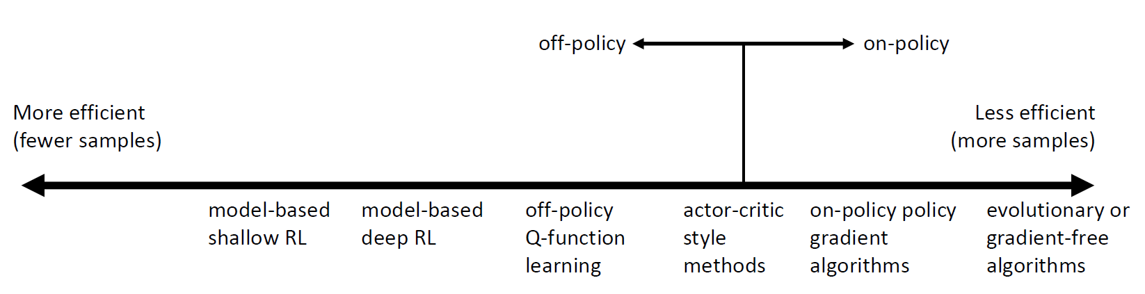

* Note that computational cost is not necessarily proportional to the number of samples
* Another issue is stability, convergence and ease of use
  + RL is often not about gradient descent, unlike supervised learning
* Comparison of various approaches in terms of assumptions
  + Value-based
    - Do not minimize expected reward, not guaranteed to converge at all in non-linear cases
    - Assume full observability
  + Model-based
    - Minimise model fitting error, but better model does not mean better policy
    - Often assume continuity or smoothness
  + Policy gradient
    - Actually optimize expected return by gradient descent or ascent
    - Assume episodic learning
* Example algorithms for each class of RL approaches
  + Value-based: Q-learning, DQN, fitted value iteration
    - Atari games with Q-functions
    - Robotic grasping with Q-functions, , Kalashnikov et al. ‘18
  + Policy gradient: REINFORCE, natural policy gradient, trust region policy optimization
    - High dimensional continuous control with generalized advantage estimation, Schulman et al. ‘16
  + Actor-critic: Asynchronous advantage actor-critic (A3C), Soft actor-critic (SAC)
  + Model-based: Dyna, Guided policy search
    - Finn et al. 2016, image-based robot manipulation

**Policy gradient methods**

* How do we evaluate the expected return? There is no analytical way to do that
* Hence, we do that by taking a sum over samples from the policy $π_{θ}$; from (1):

$${J\left(θ\right)=E}_{τ\sim p_{θ}(τ)}\left[\sum_{t}{r(s_{t},a_{t})}\right]≈\frac{1}{N}\sum_{i}{\sum_{t}{r(s_{i,t},a_{i,t})}}$$

where $i$ is the index of the sample

* By direct policy differentiation, thanks to the identity

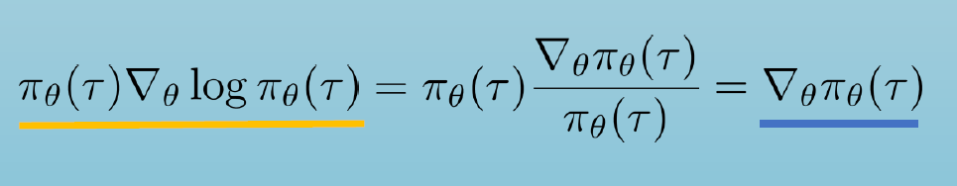

we get that

$${∇_{θ}J\left(θ\right)=E}_{τ\sim p_{θ}(τ)}[∇_{θ}\log{p_{θ}\left(τ\right)}r(τ)]$$

where $r\left(τ\right)=\sum_{t=1…T}{r(s_{t},a_{t})}$

* By using the structure (2) of $p_{θ}(τ)$ and applying the logarithm we obtain that

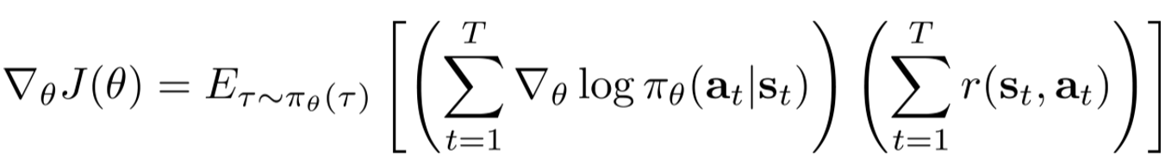

[*Actually it is $τ\sim p_{θ}(τ)$, not $τ\sim π_{θ}(τ)$* ]

* Using sample trajectories to evaluate the gradient, we further obtain

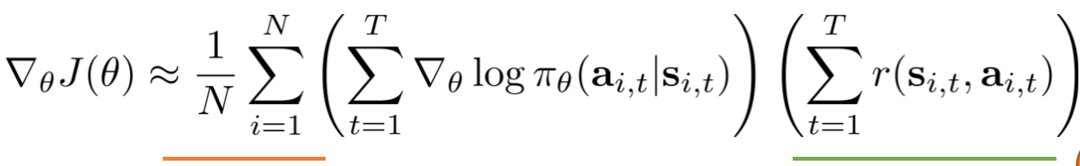 (3)

* The REINFORCE algorithm then:

1. Samples trajectories from πθ
2. Computes the approximate gradient as in (3)
3. Updates the policy parameters by gradient ascent, $θ←θ+α∇_{θ}J\left(θ\right)$

* By comparing the approximate gradient with the maximum likelihood gradient associated with the transition model, it is clear that what we are doing is increasing the probability of high reward trajectories

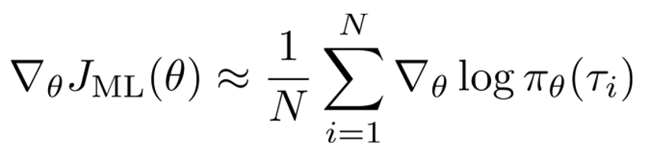

* + For example, we can sample from Gaussian policies, $π_{θ}(a_{t}|s_{t})$ is a Gaussian with as mean the output of a neural network with input $s_{t}$, and covariance $Σ$
* In the partially observable case (POMDP, in which the world is not directly observable), the same expression for the approximate gradient holds:

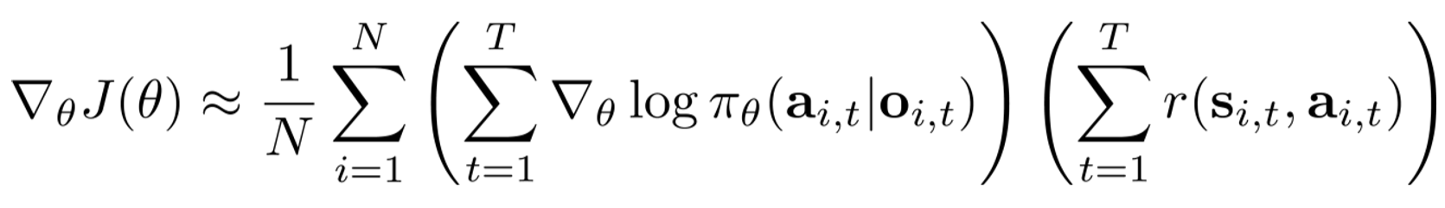 (4)

for the Markov property is not used in the derivation

* The biggest problem with policy gradient is variance: sample trajectories may wildly differ, leading to very different updates under the same conditions
* One way of reducing variance is to enforce causality (future actions/policy do not influence current reward): this translates into a sum from *t*’ to *T*, rather than from 1 to *T* in the last term of (4)
* Another way: introducing baselines
  + One choice is the average performance (total reward) of the *N* sample trajectories $$b=\frac{1}{N}\sum_{i=1}^{N}{r(τ)}$$ 
    (the reason is its expectation is zero, so the resulting estimator is unbiased)

so that the gradient becomes

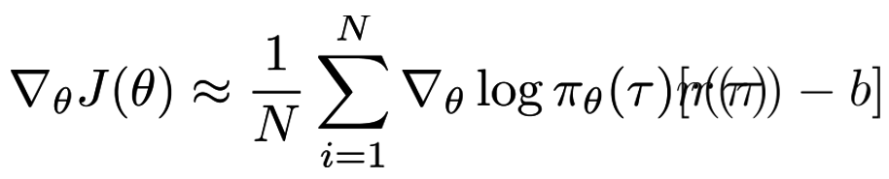

* + A better option is optimal baselines weighted by the gradient magnitudes $g(τ)$

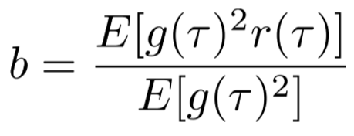

* REINFORCE is on-policy, for it needs samples at every update; can be very inefficient, for policy changes little at each step of the iteration
* We can use importance sampling to produce off-policy gradient methods
* The principle of importance sampling is that estimations with respect one probability distribution *p* can be reduced to estimations in terms of another probability distribution *q*

$$E_{x\sim p(x)}\left[f\left(x\right)\right]=E_{x\sim q(x)}\left[\frac{p(x)}{q(x)}f\left(x\right)\right]$$

If *q* is easier to sample from than *p*, this can very useful

* We want to estimate new values for the parameters $θ$ of the policy, without computing samples from the policy itself
* Using importance sampling, we can make the gradient a function of samples of the previous policy $π_{θ}(τ)$

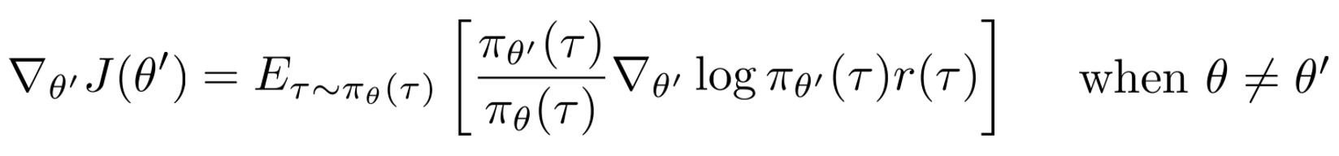

where

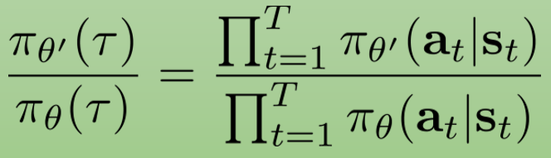

* Finally one gets the following expression for the gradient

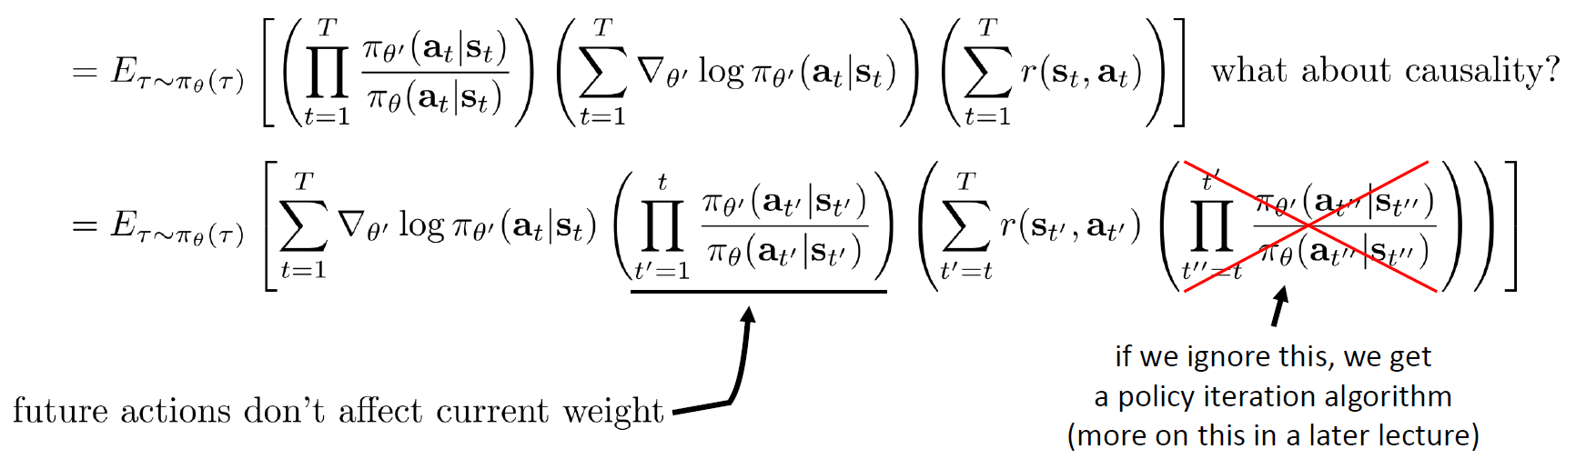

[*Actually t should be T in the term highlighted*]

* Since the IS term highlighted is exponential in T, we can use a first-order approximation

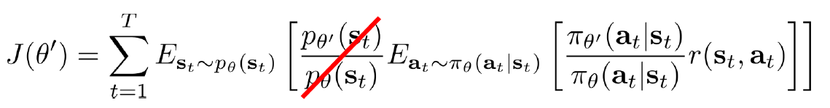

We will see how this is reasonable later in the course

* Additional variant: policy gradient with automatic differentiation [*we skip this part*]
* Policy gradient in practice
  + Unlike supervised learning, gradients have high variance [*seems to me the reason is the much larger search space in this case*], can be really noisy
  + Using much larger batches can help
  + Tweaking learning rates is very hard: we will learn about policy gradient-specific learning rate adjustment methods
* Another negative of policy gradient methods is that they zig-zag a lot back and forth when searching for the optimum
* Covariant/natural policy gradient idea: some parameters change probabilities more than others, can we rescale the gradient so that that does not happen?
* An option is to constrain the problem so that policies are not allowed to change much, as measured by the Fisher metric (KL-divergence, in practice)
* So, we pass from this update

$$θ'←θ+α∇_{θ}J\left(θ\right)$$

to this update

$θ'←\arg{\max_{θ'}{{\left(θ^{'}-θ\right)}^{T}}}∇_{θ}J\left(θ\right)$ subject to $\left\|θ^{'}-θ\right\|≤ϵ$

or

$θ'←\arg{\max_{θ'}{{\left(θ^{'}-θ\right)}^{T}}}∇_{θ}J\left(θ\right)$ subject to $D_{KL}(π_{θ'},π_{θ})≤ϵ$

* Later in the class: natural gradient and automatic step size adjustment
* Policy gradient papers
  + Classic papers
    - Williams (1992). Simple statistical gradient-following algorithms for connectionist reinforcement learning: introduces REINFORCE algorithm
    - Baxter & Bartlett (2001). Infinite-horizon policy-gradient estimation: temporally decomposed policy gradient (not the first paper on this! see actor-critic section later)
    - Peters & Schaal (2008). Reinforcement learning of motor skills with policy gradients: very accessible overview of optimal baselines and natural gradient
  + Deep reinforcement learning policy gradient papers
    - Levine & Koltun (2013). Guided policy search: deep RL with importance sampled policy gradient (unrelated to later discussion of guided policy search)
    - Schulman, L., Moritz, Jordan, Abbeel (2015). Trust region policy optimization: deep RL with natural policy gradient and adaptive step size
    - Schulman, Wolski, Dhariwal, Radford, Klimov (2017). Proximal policy optimization algorithms: deep RL with importance sampled policy gradient

**Actor-critic methods**

* Recap: the REINFORCE algorithm

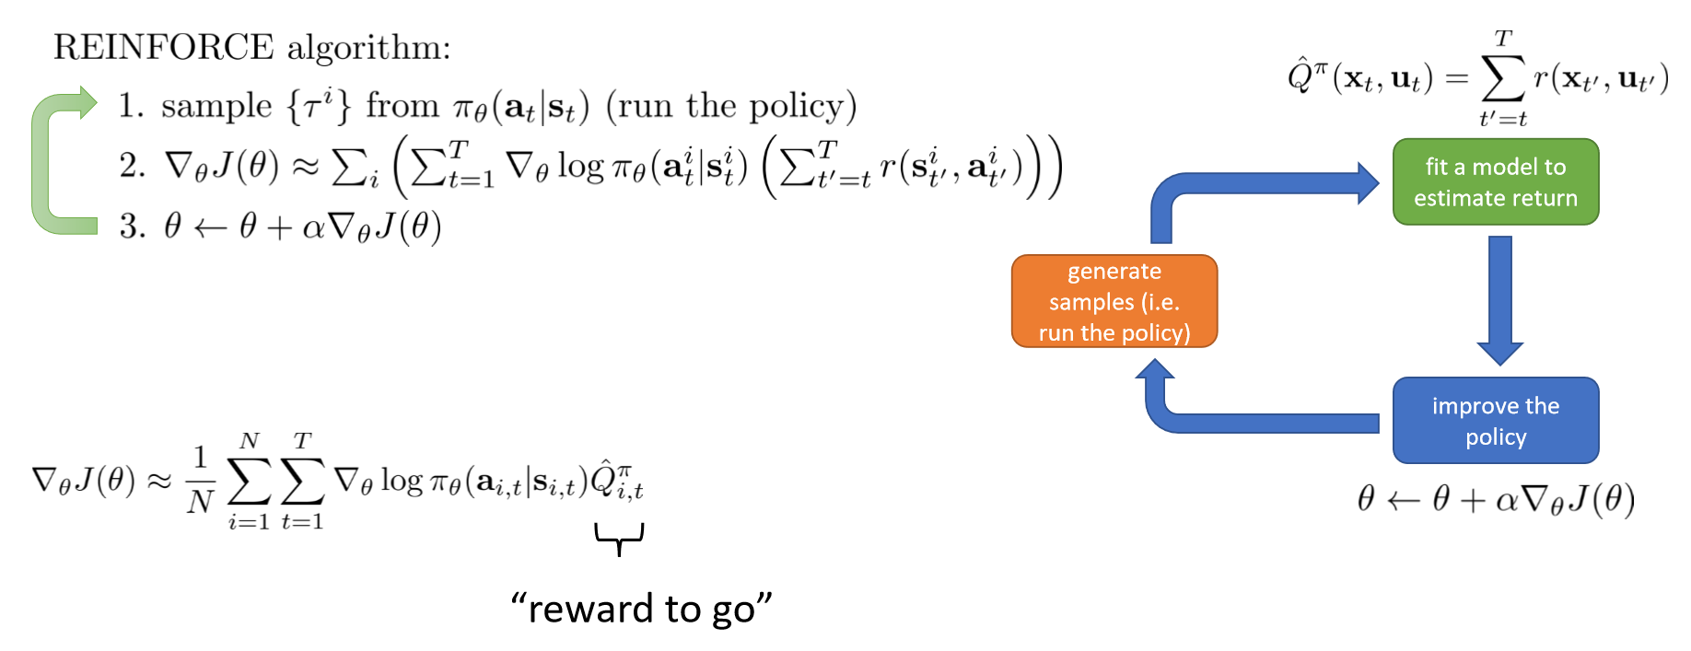

* Can we have a better estimate of future reward? We can use the true *expected* future reward under the current policy, instead – but this is nothing but the Q-function!

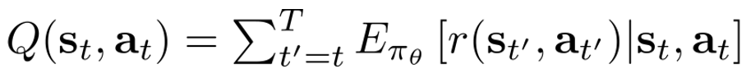

* A further option is to use its average baseline $b_{t}=\frac{1}{N}\sum_{i}{Q(s_{i,t},a_{i,t})}$
* Can we then improve the policy gradient method, using state and state-action value functions? We can write the gradient as

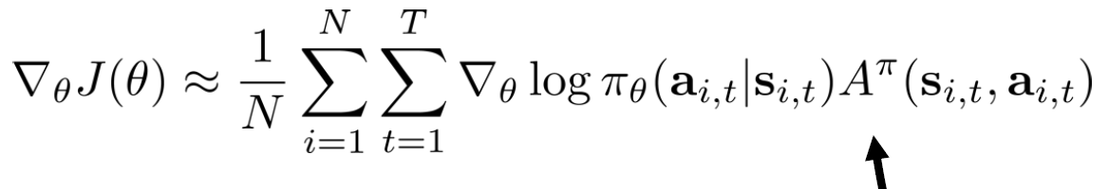

where

$$A^{π}\left(s_{t},a_{t}\right)=Q^{π}\left(s_{t},a_{t}\right)-V^{π}\left(s_{t}\right)$$

measures how much better $a_{t}$ is than the other possible actions

* The better the estimate of $A^{π}$, the lower the variance [*unclear*]
* An unbiased, but high-variance single-sample estimator of the latter is

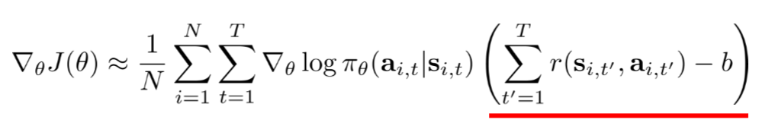

which is exactly what REINFORCE does

* The issue becomes value-function fitting (i.e., fit Q,V or Aπ), based on policy evaluation: this is the fundamental idea behind actor-critic approaches
* Note that $A^{π}$ is a function of $V^{π}$, as follows
$$A^{π}\left(s_{t},a_{t}\right)≈r\left(s_{t},a_{t}\right)+V^{π}\left(s_{t+1}\right)-V^{π}\left(s_{t}\right)$$

* $V^{π}$, in turn, can be modelled by a deep network taking the state $s$ as input, and outputting ${\hat{V}}^{π}\left(s\right)$, with parameters $ϕ$
* Policy evaluation can be performed using Monte-Carlo (just like policy gradient does)

$J\left(θ\right)=E_{s_{1}\sim p(s_{1})}[V^{π}\left(s_{1}\right)]$, $V^{π}\left(s_{t}\right)=\sum_{t^{'}=1}^{T}{E_{π_{θ}}[r\left(s_{t^{'}},a_{t^{'}}\right)|s_{t}]}$

* $V^{π}$ can be approximated as

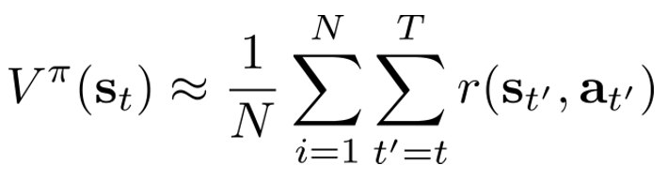

(which uses multiple samples trajectories *i*)

* A simple version uses the approximation

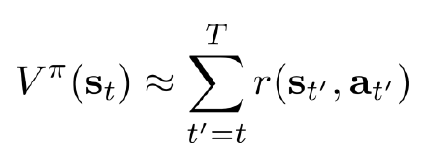

which leads to the following supervised regression problem for a network mapping $s$ to ${\hat{V}}^{π}\left(s\right)$ with parameters $ϕ$

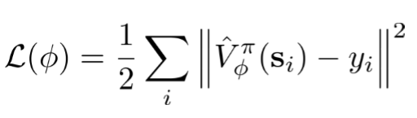 (5)

using as training data

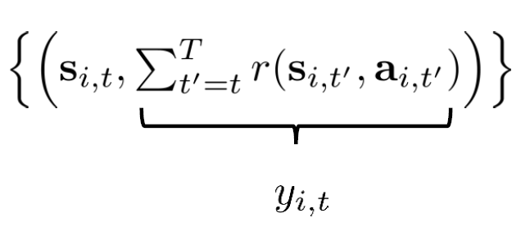

* ‘Bootstrapped’ estimates use the previously fitted value function as follows

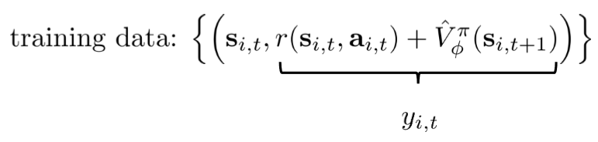

* AlphaGo is an example of policy evaluation approach - the value function ${\hat{V}}^{π}\left(s\right)$ is the expected outcome given the board state
* What is T becomes infinite? ${\hat{V}}^{π}\left(s\right)$ can become infinitely large as we keep summing over more and more time instants
* The solution is to use a discount factor γ in [0,1] to achieve reward sooner rather than later
$$y_{i,t}≈r\left(s_{i,t},a_{i,t}\right)+γ{{\hat{V}}_{ϕ}}^{π}\left(s_{i,t+1}\right)$$

* There are various ways of applying discount factors to the gradient, which have different effects: consult “Philip Thomas, Bias in natural actor-critic algorithms. ICML 2014”
* Summary of actor critic algorithms with discount

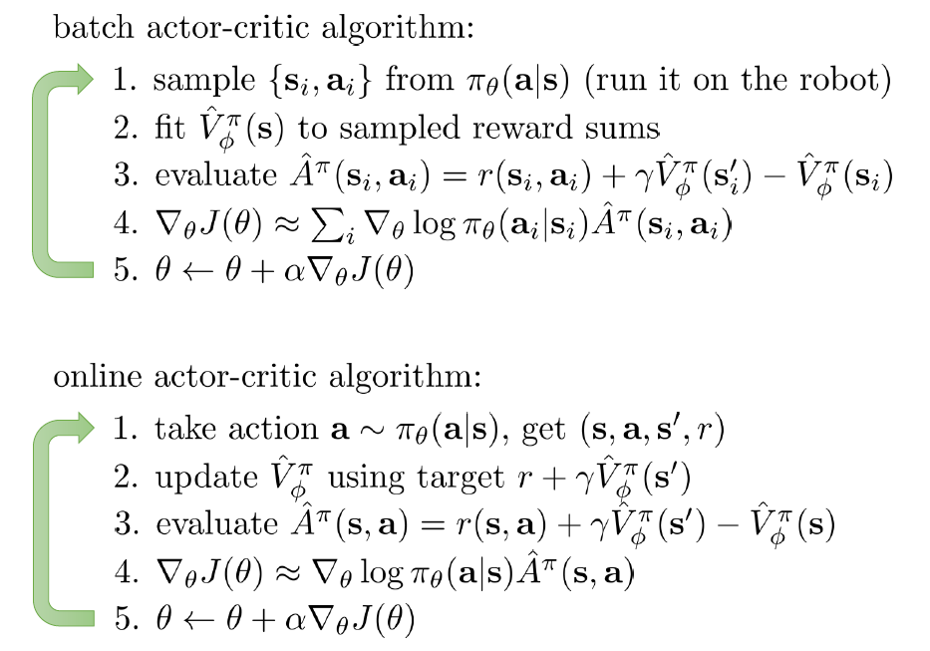

[*Step 2 of the batch algorithm consists on solving the regression problem (5)*]

* Actor-critic algorithms can be either batch or online
* The term actor-critic refers to the role of the (network implementing the) policy (actor), in opposition to that of the (network implementing the) estimator of future reward (critic)
* On the architecture: the networks that output policy (actor) and value function (critic) can be separate, or shared

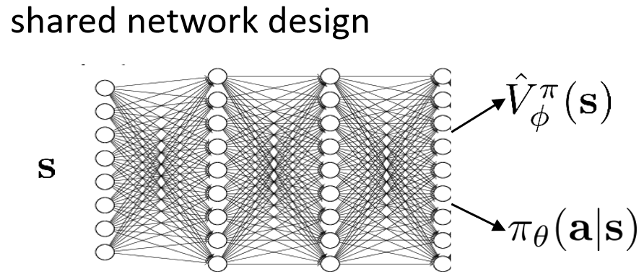

* Synchronized or asynchronous workflows can also be adopted

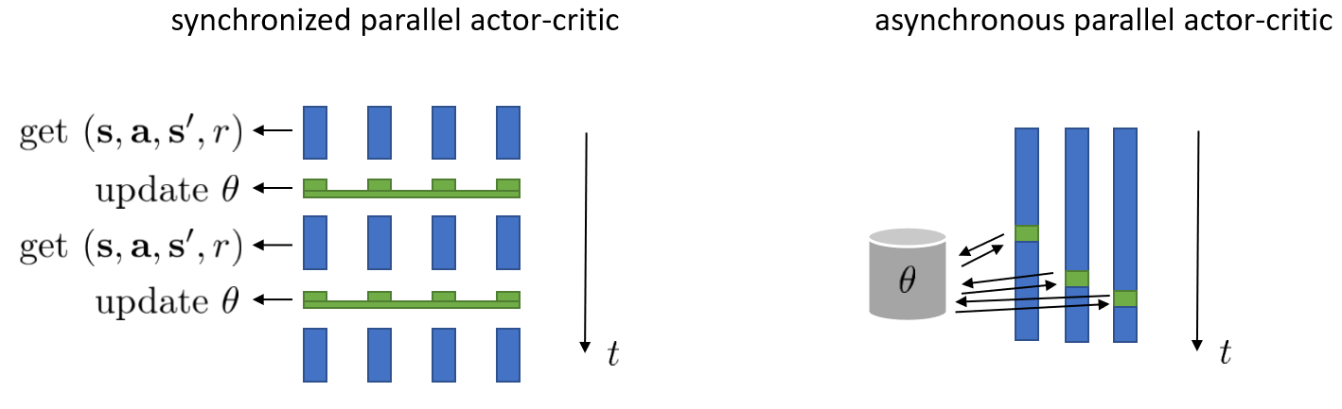

* Comparison between actor-critic and policy gradient



* + Lower variance (due to critic), but not unbiased (if critic is not perfect)

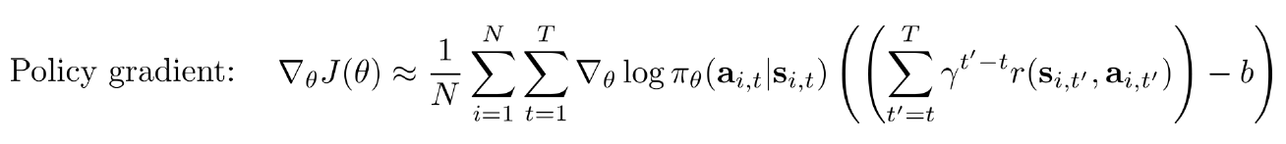

* + No bias, but higher variance (because of the single-sample estimate)
* BUT we can use the critic and still keep the estimator unbiased

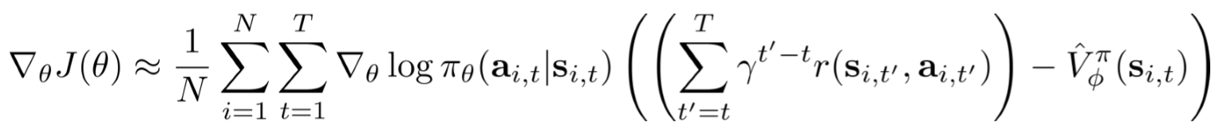

* Action-dependent baselines can be used, thanks to the Q-function

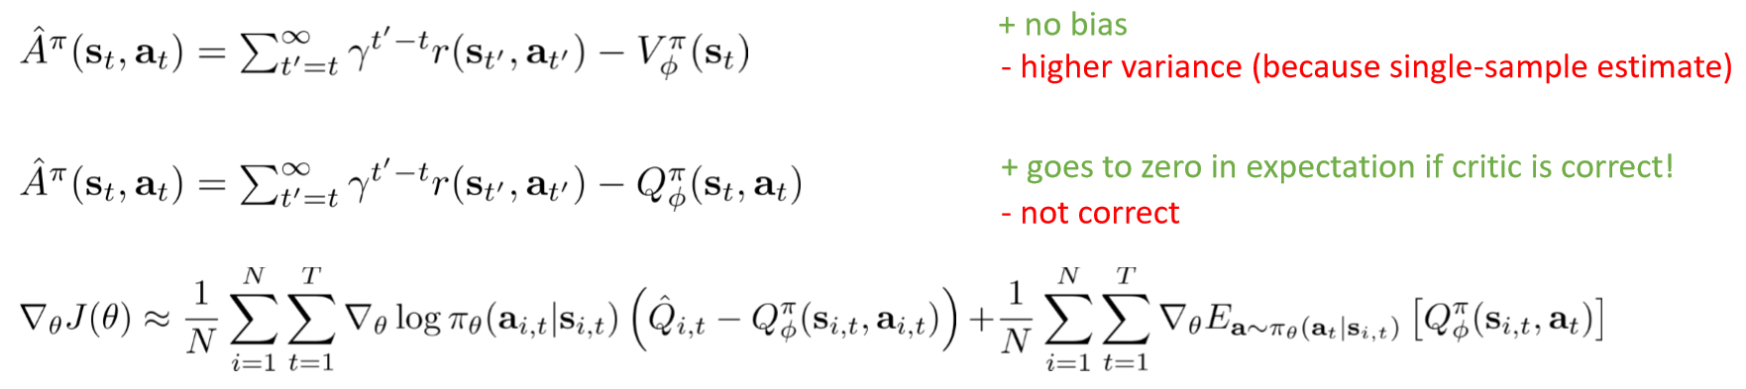

* Actor-critic examples:
  + High dimensional continuous control with generalized advantage estimation (Schulman, Moritz, L., Jordan, Abbeel ’16 (batch)
  + Asynchronous methods for deep reinforcement learning (Mnih, Badia, Mirza, Graves, Lillicrap, Harley, Silver, Kavukcuoglu ‘16), online, single network for actor and critic
* Actor-critic papers:
  + Classic papers
    - Sutton, McAllester, Singh, Mansour (1999). Policy gradient methods for reinforcement learning with function approximation: actor-critic algorithms with value function approximation
  + Deep reinforcement learning actor-critic papers
    - Mnih, Badia, Mirza, Graves, Lillicrap, Harley, Silver, Kavukcuoglu (2016). Asynchronous methods for deep reinforcement learning: A3C -- parallel online actor-critic
    - Schulman, Moritz, L., Jordan, Abbeel (2016). High-dimensional continuous control using generalized advantage estimation: batch-mode actor-critic with blended Monte Carlo and function approximator returns
    - Gu, Lillicrap, Ghahramani, Turner, L. (2017). Q-Prop: sample-efficient policy gradient with an off-policy critic: policy gradient with Q-function control variate

**Value function methods**

* The principles of value-function methods are
  + Using a critic without an actor.
  + Extracting a policy from a value function.
* The practical implementation is these principles involves
  + The Q-learning algorithm.
  + Practical considerations, extensions (continuous actions, improvements).
* The idea is to omit policy gradient completely

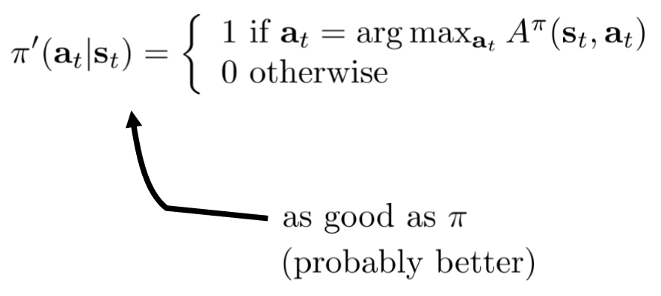 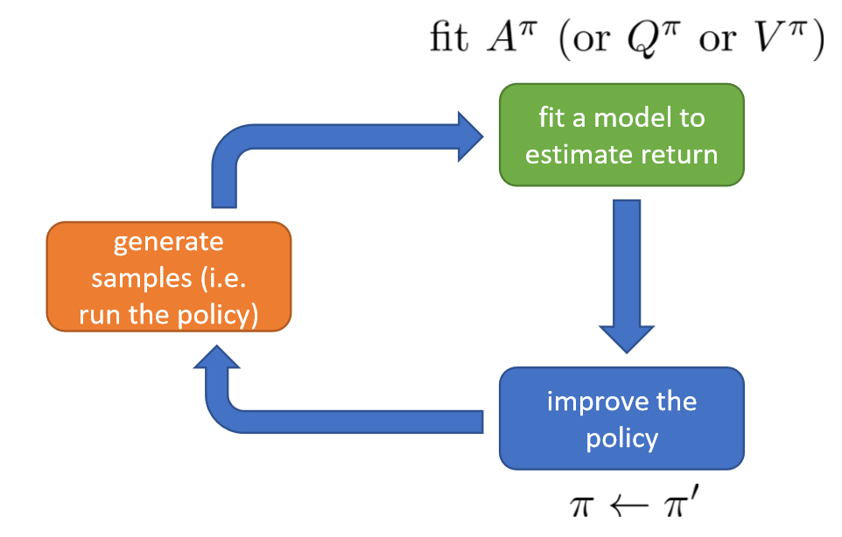

[*The name is quite misleading, actually, for actor-critic methods also use the value function*]

* That is because argmax … is as good as any $a_{t}\sim π\left(a_{t} | s_{t}\right)$, regardless of what $π$ is
* Policy iteration algorithm
  1. Evaluate $A^{π}\left(s,a\right)=r\left(s,a\right)+γE\left[V^{π}\left(s^{'}\right)\right]-V^{π}(s)$ (same as in actor-critic).
  2. Update $π$.
  + So, step 1 reduces to evaluating $V^{π}$
* Now, assume that we know $p(s^{'}|s,a)$, and that $s$ and $a$ are both discrete and small
* Then, the transition probability can be stored in a small table, and step 1 can be done using bootstrapped update, in a dynamic programming setting

Step 1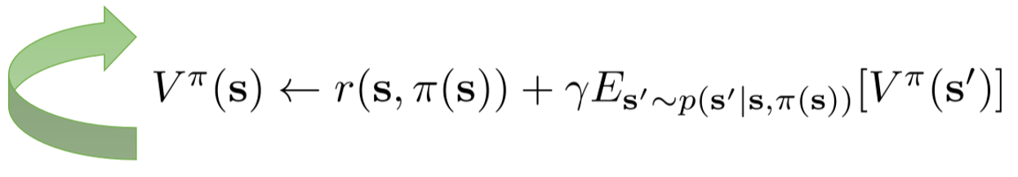

Step 2 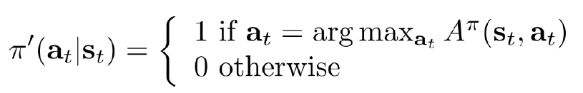

* + Note: the policy $a=π(s)$ is deterministic
* The Q-function can be used instead of $A^{π}$ in a simplified dynamic programming strategy

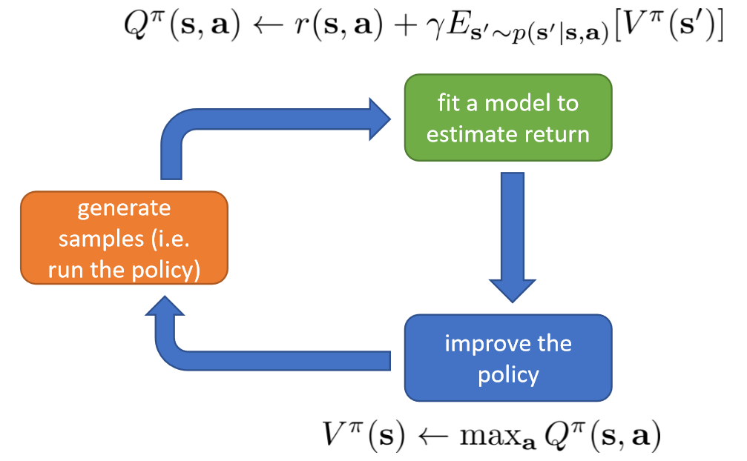

* This is because



* The table-based approaches seen so far incur the curse of dimensionality: that’s why we use a neural net to represent $V^{π}(s)$ (as in actor-critic)
* The result is the fitted-valued iteration algorithm for estimating $V^{π}$ (the first step of policy iteration)

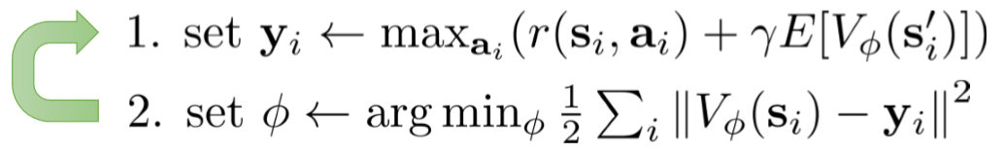

* This algorithm minimizes the objective function

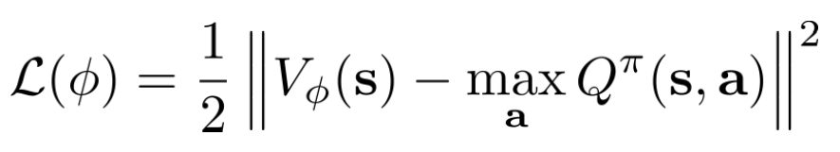

* This algorithm (implicitly) requires the knowledge of $s^{'}\sim p(s^{'}|s,a)$: at step 1 one needs to know the outcomes of the different actions in order to compute $s_{i}^{'}$ and therefore $V_{ϕ}(s_{i}^{'})$
* Can we do the same (forget policy, compute parameter values directly) with Q values, without knowing the transitions?
* We obtain the fitted Q-iteration algorithm

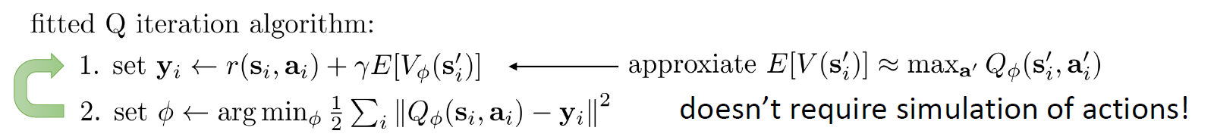

* Advantages:
  + Works even for off-policy samples (unlike actor critic)
  + Only one network, no high variance policy gradient
* Disadvantages:
  + No convergence guarantees for nonlinear function approximation
* [*To me, this is still a function of the transition probabilities, for $s^{'}$ is still in there*]
* The way they fix this is by collecting a dataset by running some collection policy

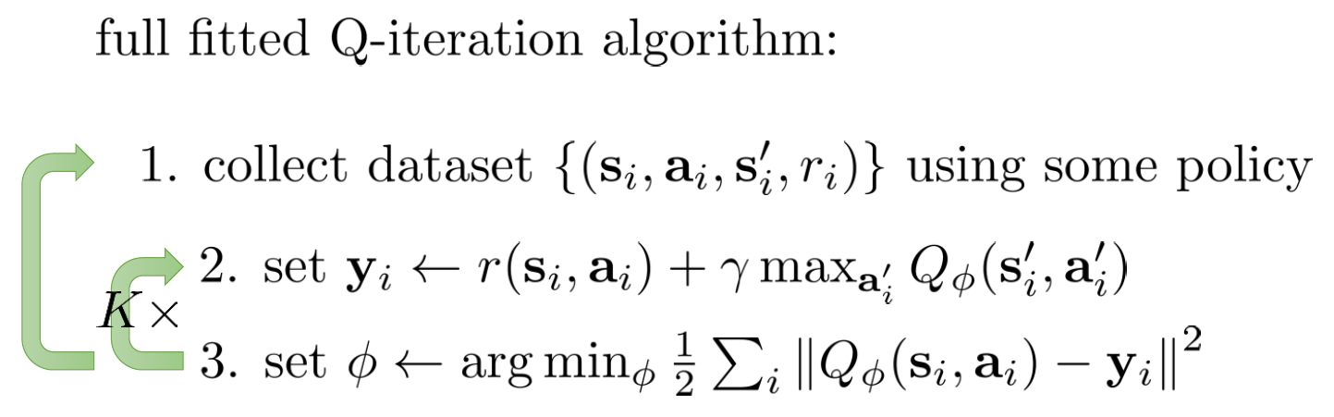

* Its parameters are: the size *N* of the dataset, the collection policy, the number of iterations *K* and the gradient steps *S* in step 3
* Only one network is required, for $Q_{ϕ}(s,a)$, with parameters $ϕ$
* It is off-policy, for it does not sample from the new policy to update, but uses a dataset of transitions

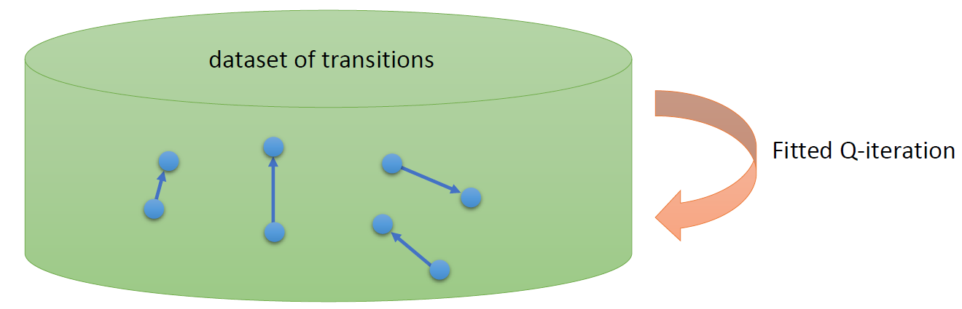

* Given $s$ and $a$, the transition is independent of $π$

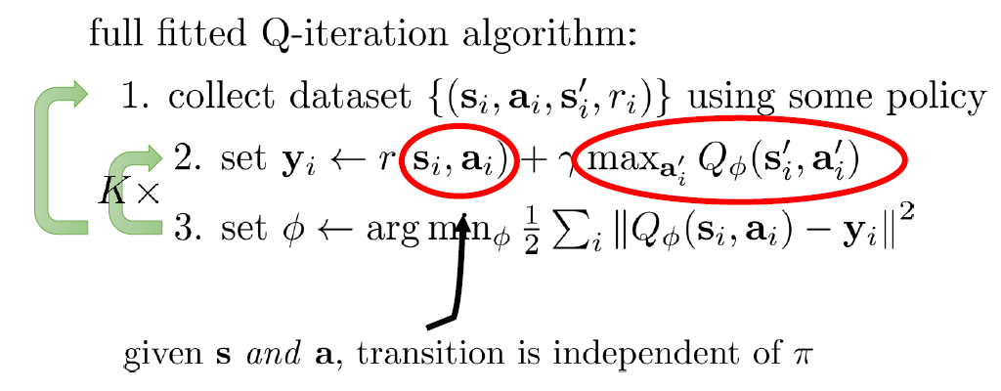 (6)

* What does fitted Q-iteration optimize? It maximizes the expected reward when the error (point 3 in the above algorithm) tends to zero

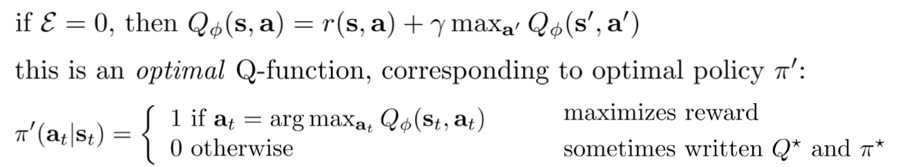

* [Note that most guarantees are lost when using a neural network approximation $Q_{ϕ}$, unlike the tabular case]
* Online Q-learning algorithm

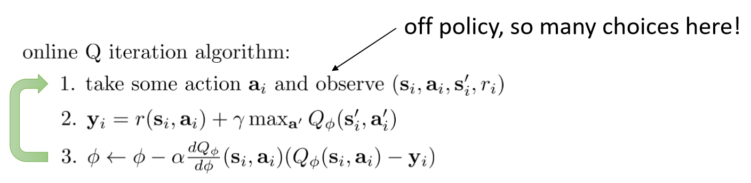

* In practice, setting the policy to 1 when $a_{t}=\arg{\max_{a_{t}}{Q_{ϕ}(s_{t},a_{t})}}$ is a bad idea in the initial steps
* Exploration strategies are used instead
  + Epsilon-greedy

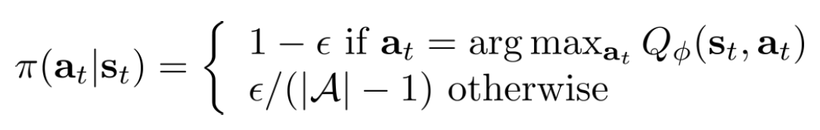

* + Boltzmann

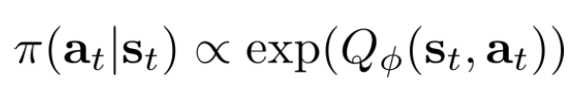

* Value function learning theory shows that the optimal value function $V$ in the value iteration algorithm always exists, is always unique, and always corresponds to the optimal policy
  + Let us define an operator

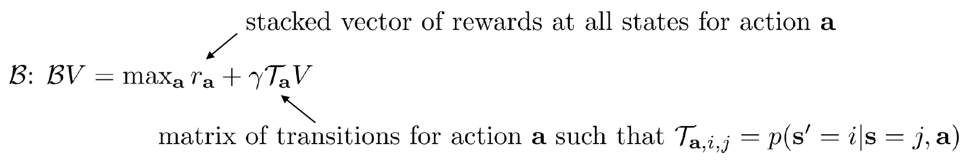

* + Then, $V^{*}$ is a fixed point of



* + Always exists, always unique, always corresponds to the optimal policy $π'$ as defined above
* It can be proved that value iteration reaches $V^{*}$, because the operator $B$ that corresponds to it is a *contraction*:

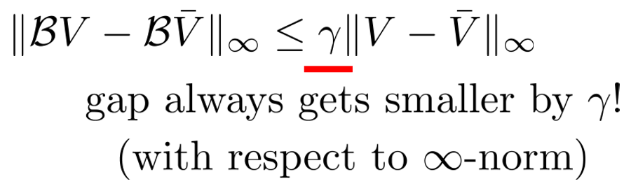

* Unfortunately, fitted-value iteration (instead) does not converge, for it involves a projection Π onto the space generated by the model used (e.g. a neural network): V ← ΠBV, and ΠB is not a contraction

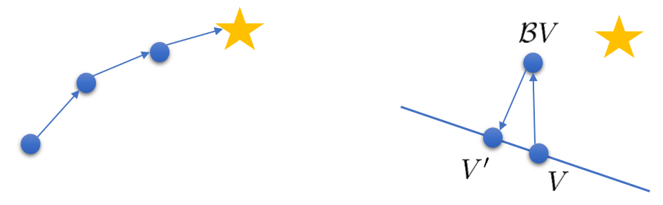

* + This happens in step 2 of the algorithm (6)
  + We can show this is equivalent to defining a projection operator

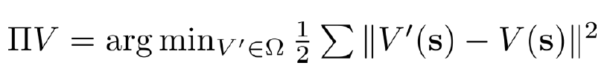

where $Ω$ is the space of all the value functions being represented (e.g. by a certain NN)

* The same holds for fitted Q-iteration
* Q-learning is not gradient descent, so it also does not converge

**Deep reinforcement learning with Q-functions (Week 8)**

* Outcomes
  + Q-learning with deep networks
  + A generalized view
  + Q-learning in practice
  + Continuous Q-learning
* Besides the issue with convergence, Q-learning has a problem with correlated samples

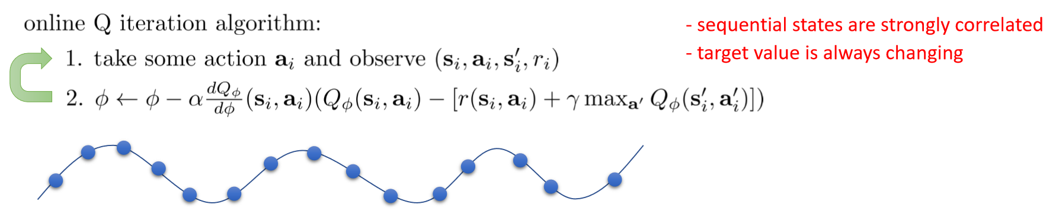

* Note: this point is not quite well explained in the slides, need to read: does not a policy produce samples in a sequence too (see below)?
* Alternative: full Q-learning with replay buffer

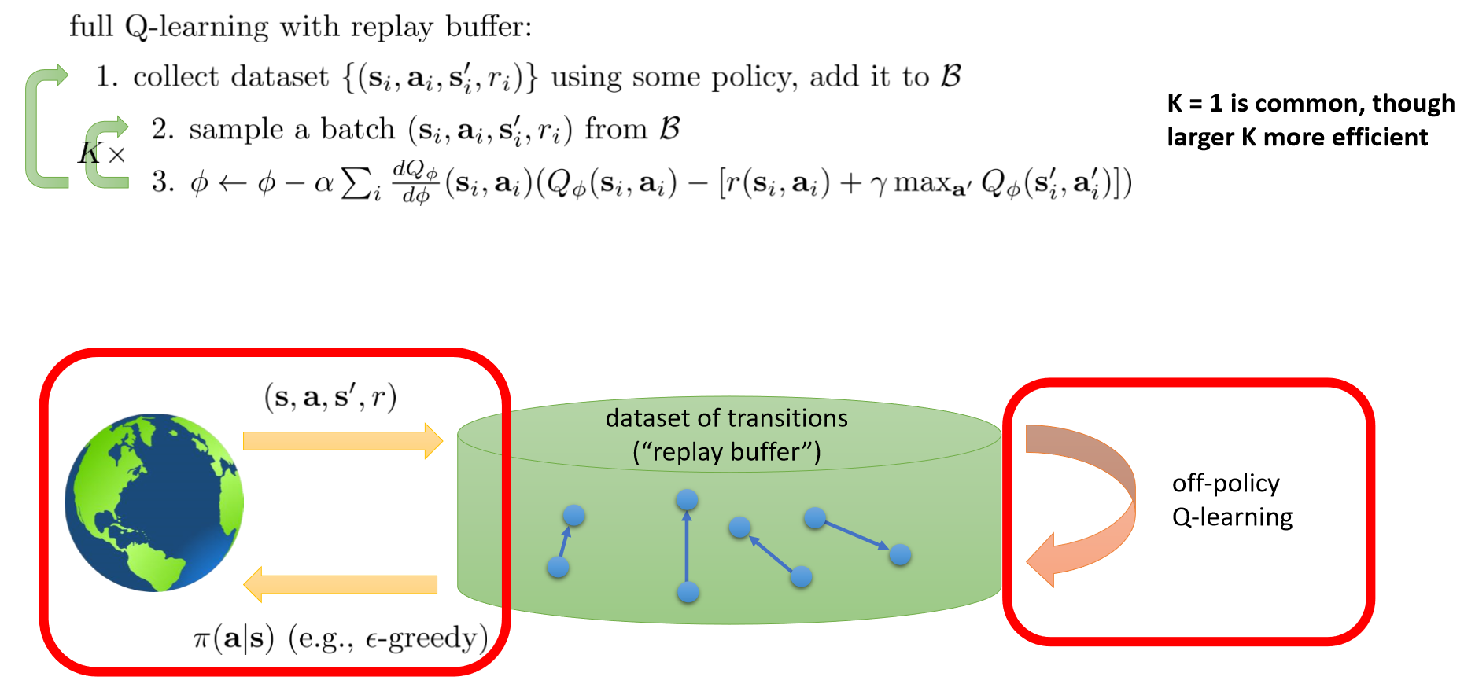

* The real point seems to be that the gathering of the data is completely separated from the learning
* You apply a sequential algorithm to sequences of samples randomly extracted from a dataset
* Previous experience is reused multiple times
* Apparently the data are more iid, as assumed in most convergence proofs
* The other problem is that the target keeps moving

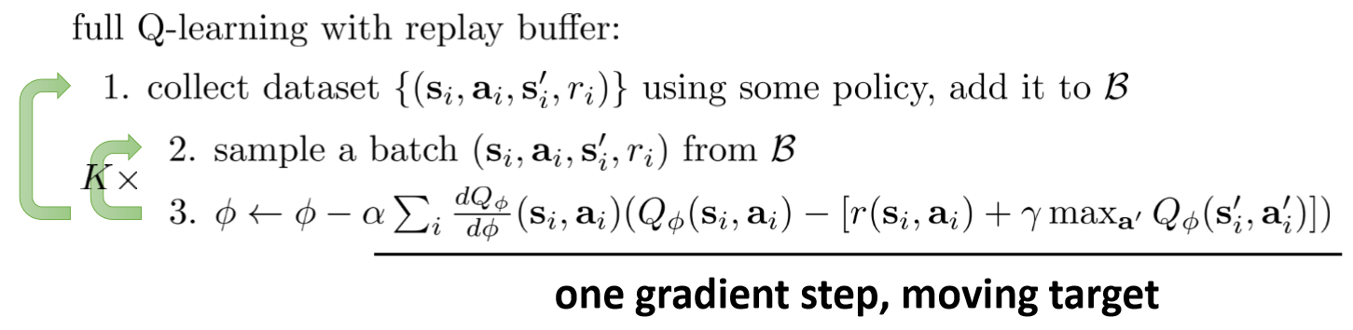

* A solution is provided by Q-learning with target networks

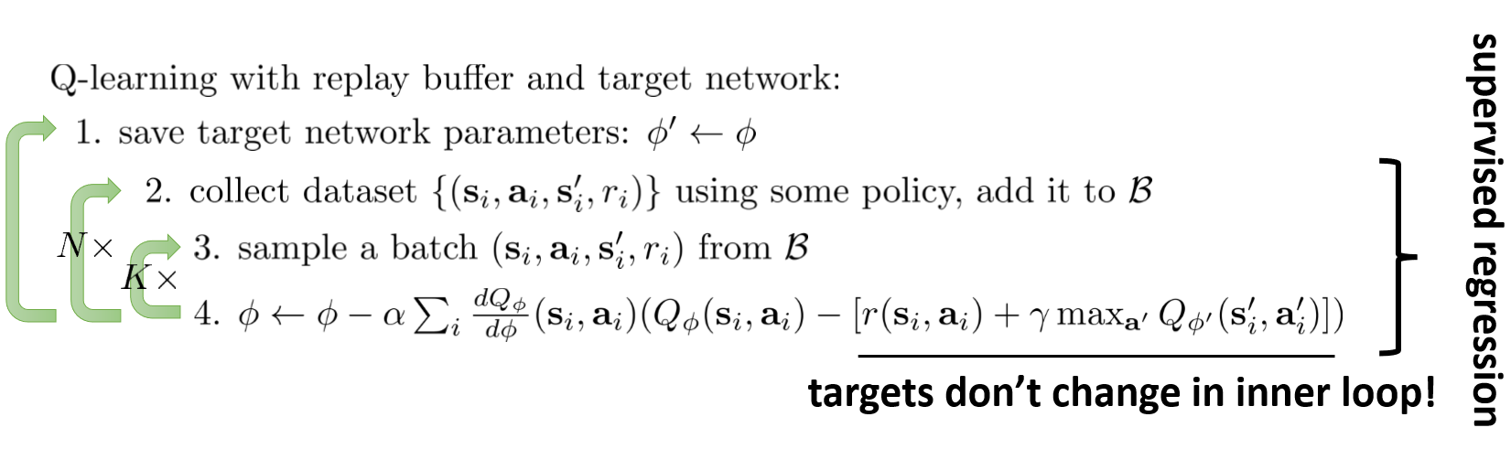

* Classic Deep Q Learning algorithm (Mnih et al. ’13, “Playing Atari with Deep Reinforcement Learning”)

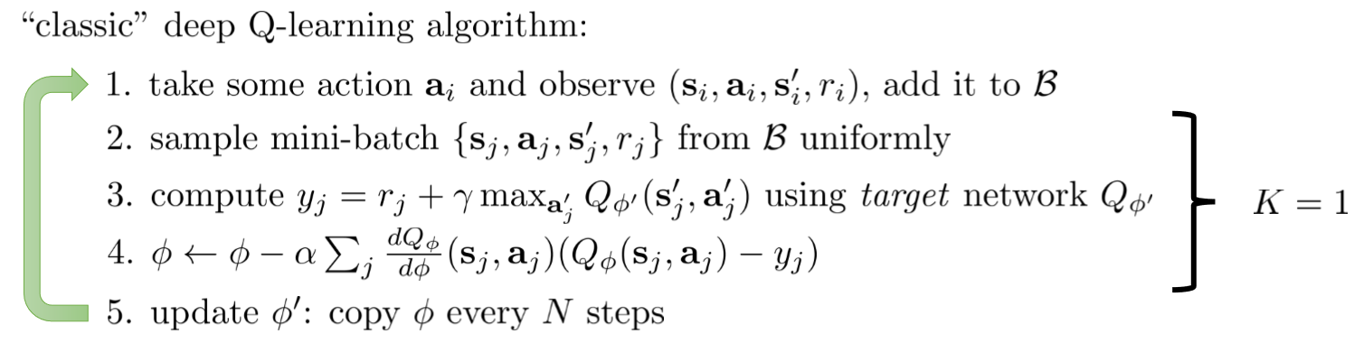

* The target network, implementing the Q function, is updated every N steps
* This generates an unequal lag among the updates triggered by the different sample mini-batch

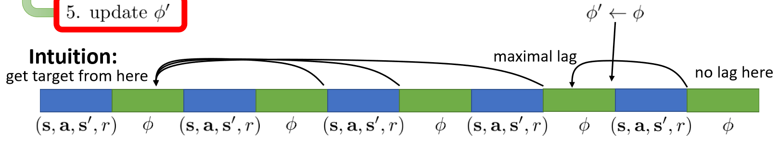

* Overall view of Q-learning with replay buffer and target network:

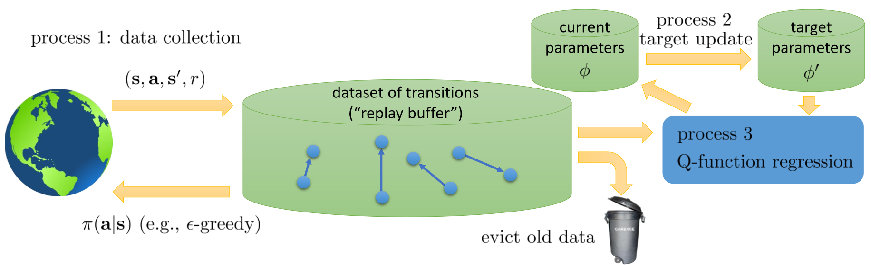

* Difference among the methods we saw:
  + Online Q-learning (last lecture): evict immediately, process 1, process 2, and process 3 all run at the same speed
  + DQN: process 1 and process 3 run at the same speed, process 2 is slow
  + Fitted Q-iteration: process 3 in the inner loop of process 2, which is in the inner loop of process 1

Q-functions have an overestimation problem FINISH THIS

**Advanced policy gradient (Week 9)**

* Topics:
  + Why does policy gradient work?
  + Policy gradient is a type of policy iteration
  + Policy gradient as a constrained optimization
  + From constrained optimization to natural gradient
  + Natural gradients and trust regions
* Contents of part 1
  + Policy gradient = policy iteration
    - Evaluate advantage of old policy
    - Maximize advantage w.r.t. new policy
  + Correct thing to do is optimize expected advantage under new policy state distribution
  + Doing this under old policy state distribution optimizes a bound, if the policies are close enough
  + Results in constrained optimization problem (constraint is that the KL divergence of the two policies is smaller than ε)
* Contents of part 2
  + First order approximation to objective = gradient ascent
  + Regular gradient ascent has the wrong constraint
  + Taylor expansion of KL-divergence = natural gradient
  + Practical algorithms
    - Natural policy gradient
    - Trust region policy optimization

**Model-based reinforcement learning 1 (Week 10)**

* Topics
  + Introduction to model-based reinforcement learning
  + What if we know the dynamics? How can we make decisions?
  + Stochastic optimization methods, and Monte Carlo tree search
  + Trajectory optimization: backward recursion, iterative LQR methods
* Recap: RL objective

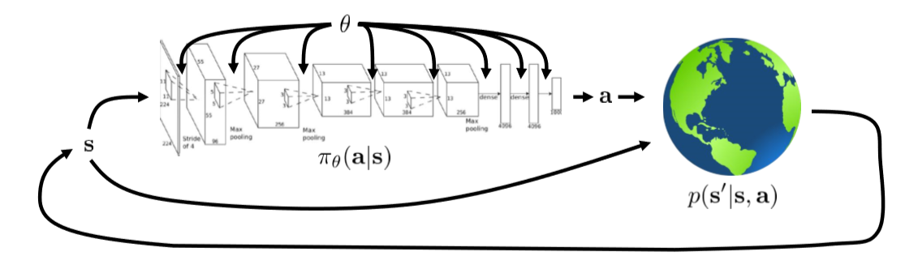

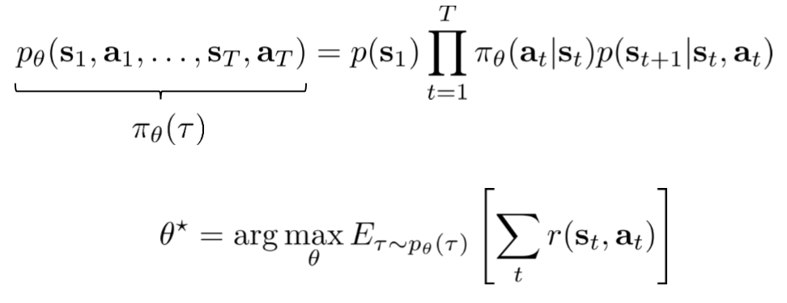

* Model-free RL assumes p(s|s,a) is unknown
* However: often we do know the dynamics (e.g. in games), or we can learn them (via learning or system identification)
* Model-based reinforcement learning: learn the transition dynamics, then decide how to pick actions
* How can we choose actions under perfect knowledge of the system dynamics?

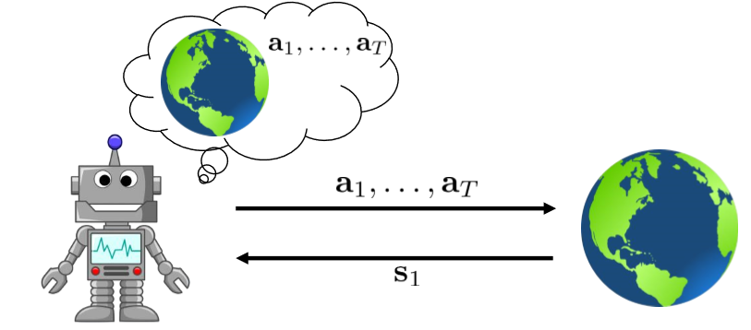

* The deterministic case (in which one action follows from a certain state,action pair)

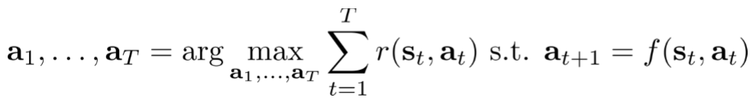 (10.1)

* The stochastic (open loop) case (in which the series of actions deliver series of states with attached probabilities):

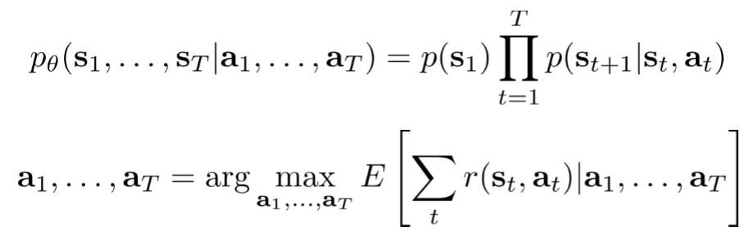

* Open loop: state is only acquired at t=1, then the machine needs to figure out the whole sequence a1…aT (as opposed to closed loop, in which after each at the robot can measure st, and at is sampled from the policy π(at|st))
* Stochastic closed loop:

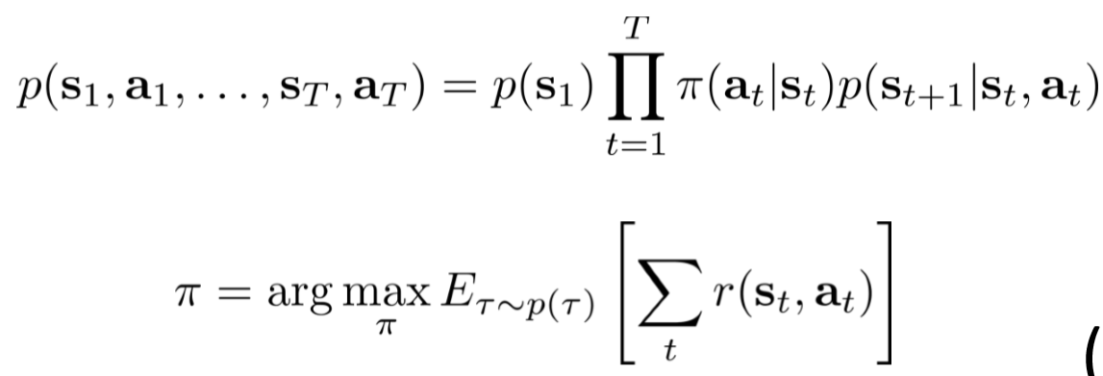

* Naïve stochastic optimization:
  + Pick some samples of the sequence a1,…,aT
  + Choose the sample value that optimizes the objective function (this is an expectation which is a function of p(s|s,a), i.e., of the dynamics)
* Cross-entropy method (CEM):
  + Pick the samples from some distribution (typically Gaussian)
* Positives
  + Very fast if parallelized
  + Very simple
* Negative
  + Harsh dimensionality limit
  + Only for open-loop planning
* In the discrete case, Monte-Carlo tree search can be used
* However, we cannot search all paths:
  + Where to search first?
  + How to approximate the value without the full tree?

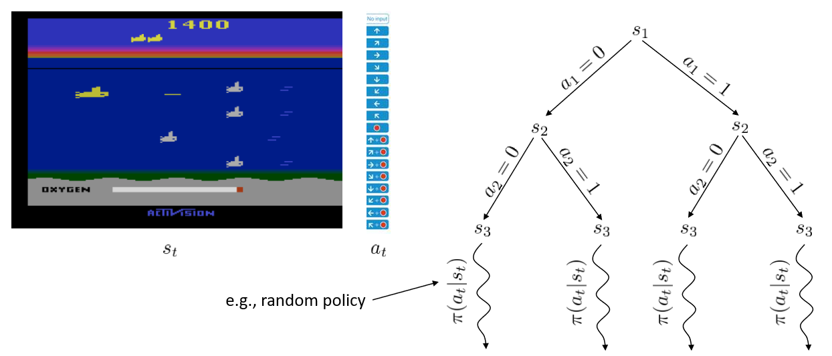

* Intuition: chose nodes with best rewards, but also prefer seldom visited nodes

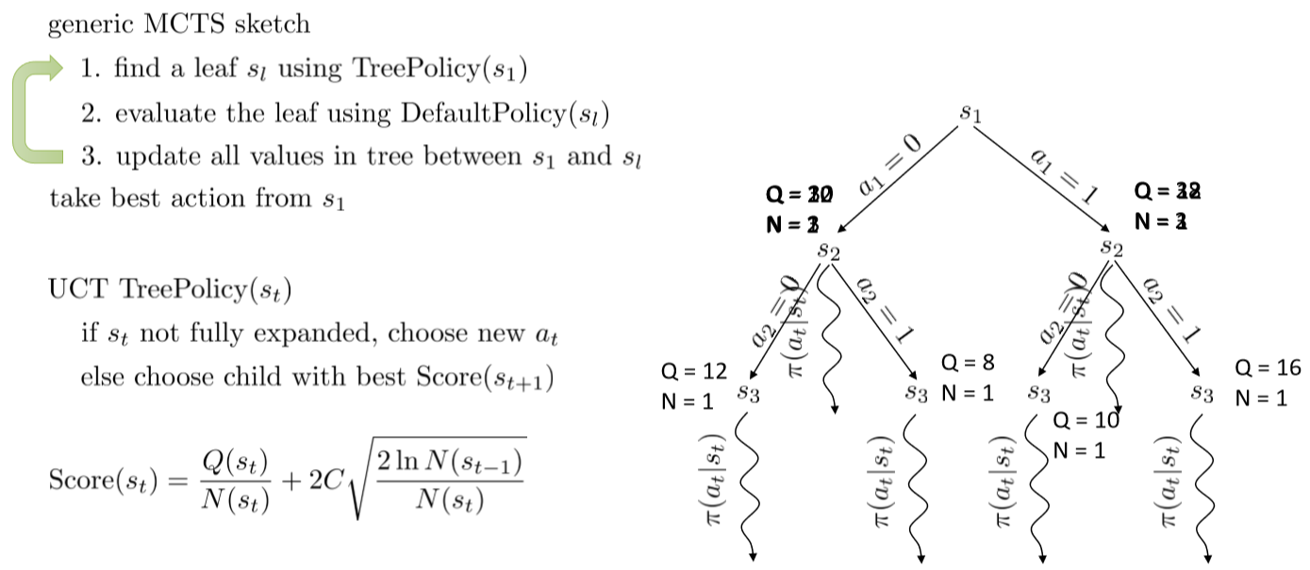

* Survey: Browne, Powley, Whitehouse, Lucas, Cowling, Rohlfshagen, Tavener, Perez, Samothrakis, Colton. (2012). A Survey of Monte Carlo Tree Search Methods.
* Case study: imitation learning using MCTS – Deep learning for real-time Atari game play using offline Monte-Carlo tree search planning

**Trajectory optimization**

* In the deterministic case, the problem (10.1) can be rewritten as
$$\min_{a_{1},…,a_{T}}{r\left(s_{1},a_{1}\right)+r(f\left(s_{1},a_{1}\right),a_{2})}+…+(f\left(f(f(…))\right),a_{T})$$

* After that one can differentiate via back-propagation and optimize
* Shooting method: optimize over actions only
* Collocation method: optimize over actions and states with the usual constraint on the dynamics

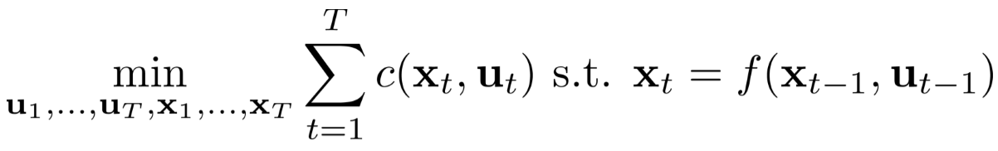

* (*Mind the change of names of variables sometimes in the slides*)
* LQR case: f is linear, and r/c is quadratic

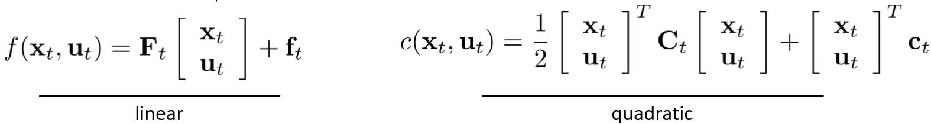

* By exploiting the dependencies between the uts and the xts we get a backward recursion algorithm (*see slides for the definition of the various quantities*)

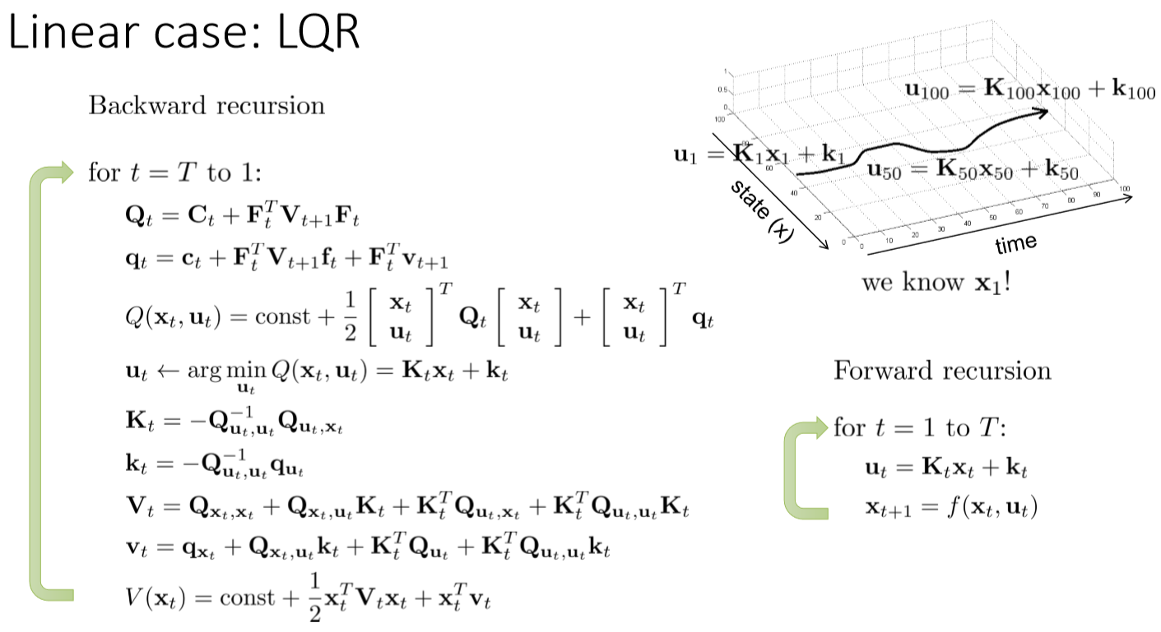

* This holds for the stochastic dynamics case as well:

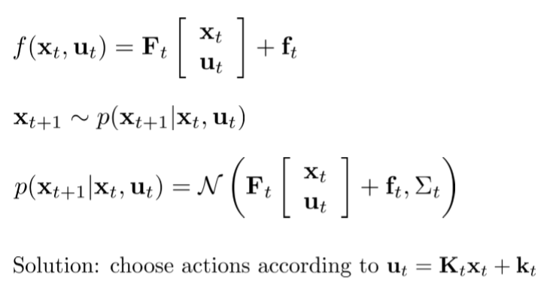

* Assumes actions are an affine function of the states; transition probability is Gaussian, with mean a linear function of the pair state, action
* Nonlinear case: nonlinear dynamics are approximate with a linear-quadratic system using local gradients and Laplacians
* Iterative LQR algorithm:

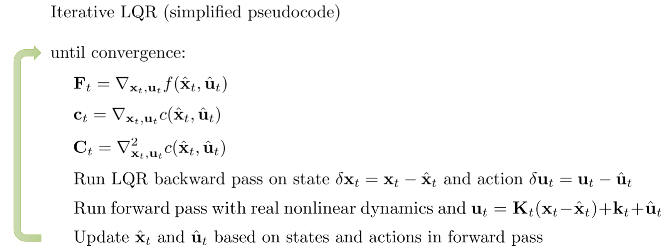

* Relates to Newton’s method in differential dynamic programming (DDP)
* The latter is not a good idea, for second-order approx. can lead to moving to a worse sample

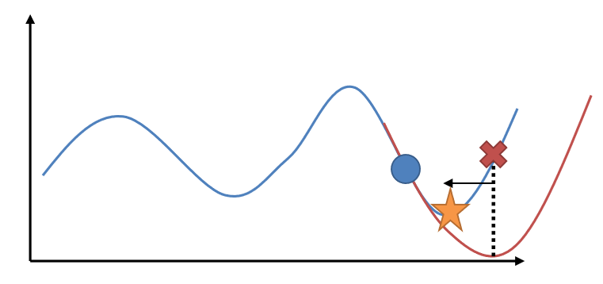

* Additional reading:
  + Mayne, Jacobson. (1970). Differential dynamic programming.
    - Original differential dynamic programming algorithm.
  + Tassa, Erez, Todorov. (2012). Synthesis and Stabilization of Complex Behaviors through Online Trajectory Optimization.
    - Practical guide for implementing non-linear iterative LQR.
  + Levine, Abbeel. (2014). Learning Neural Network Policies with Guided Policy Search under Unknown Dynamics.
    - Probabilistic formulation and trust region alternative to deterministic line search.

**Model-based reinforcement learning 2 (Week 11)**

* Topics (not so much about ‘deep’ in this lecture)
  + What to do is dynamics are unknown? How can we learn them?
    - Fitting global dynamics models (“model-based RL”)
    - Fitting local dynamics models
  + How can we then also learn policies? (e.g. by imitating optimal control)
  + Learning with local models and trust regions
* Bottom line: learning the dynamics (s = f(s,a) or π(s,a)) from the observed data, so that we can use the methods of Week 10
* Base version (v0.5):

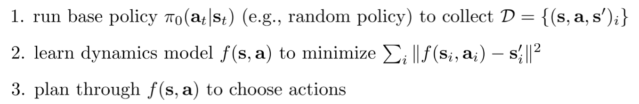

* Similar to the way system identification works in classical robotics, works reasonably
* Useful if we have prior info about the physics, can design a good base policy
* Problem: there is a mismatch between the base policy that generates the data we learn from, and the final policy (distribution mismatch)

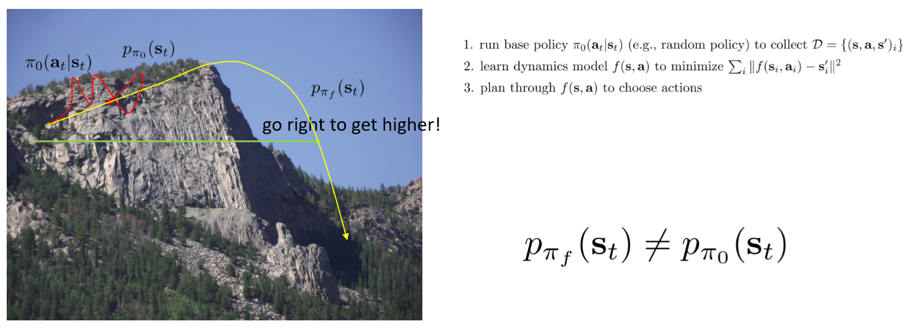

* Better version of model-based reinforcement learning (v1.0):

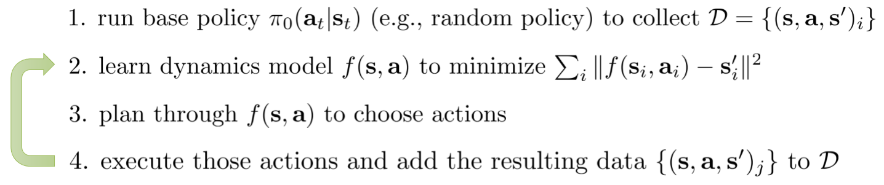

* Basically, iterates through the learnt model to keep expanding the data we learn from
* Version that accounts for mistake we might make along the way (v1.5):

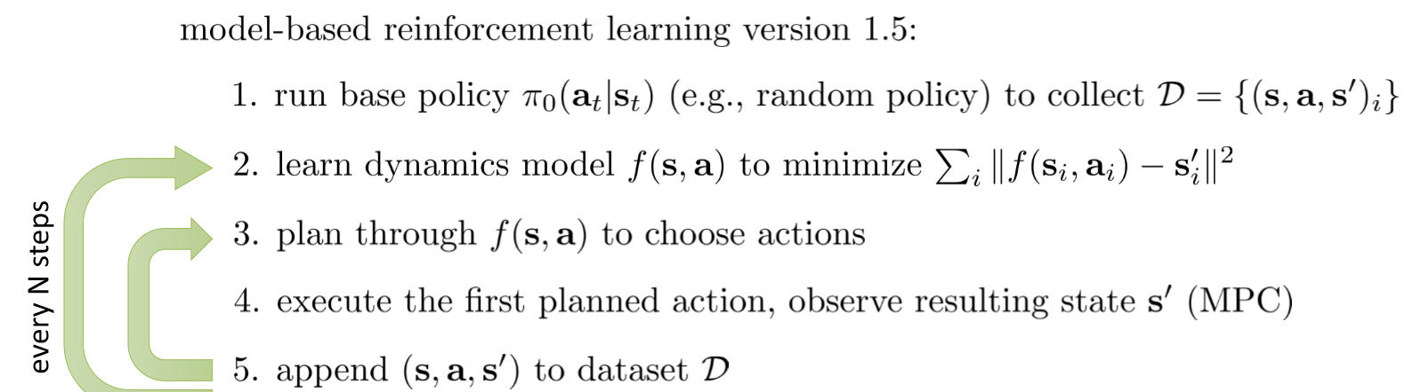

* Idea: re-planning helps with model errors
  + The more one replans, the less perfect each individual plan needs to be
  + Can use shorter horizons
  + Random sampling can often work
* However, can be computationally very expensive
* Back-propagating directly into the policy (v2.0)

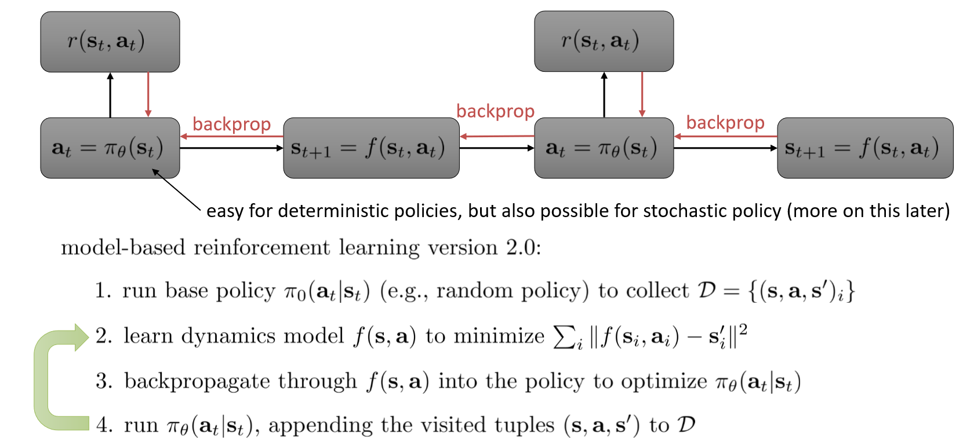

* Basically, instead of trying all possible combinations of actions (planning), we exploit the network structure/dependency to optimize the policy via backpropagation
* Computationally cheaper at runtime, but can be numerically unstable especially in the stochastic case
* Example paper: Learning to control a low-cost manipulator using data-efficient reinforcement learning, by Deisenroth et al (uses a GP dynamics model for p(s’|s,a))
* What kind of models can we use?
  + Gaussian processes
  + Neural networks
  + Gaussian Mixture Models, etc

**Global versus local models**

* Problem with global models: planner will seek regions in which the model is erroneously optimistic: this requires a very good model in most of state space
* Can use local models instead: just fit the derivatives $\frac{∂f}{∂x_{t}},\frac{∂f}{∂u_{t}}$ around current trajectory/policy

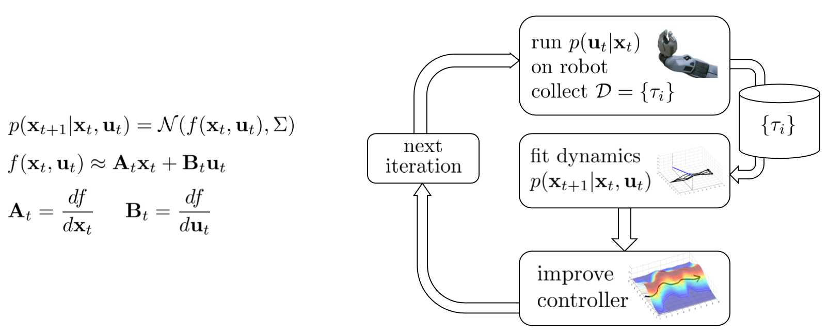

* Stage 3: the controller
* There are different options as to the controller to execute
* Given that iLQR will produce: ${\hat{x}}_{t},{\hat{u}}_{t},K_{t},k_{t}$, , these are:

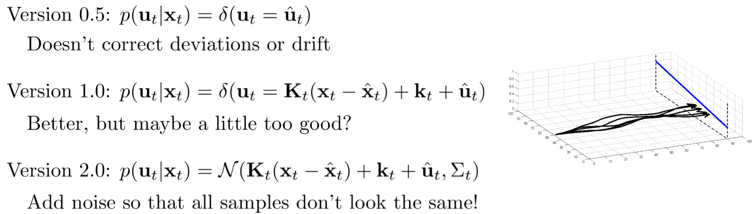

* Stage 2: fitting the dynamics
* Given the collected dataset $D=\{{\left(x_{t},u_{t},x_{t+1}\right)}_{i}\}$
  + v1.0: using linear regression at each step



* + v2.0: using Bayesian linear regression (using your favourite model as prior: GP, DN, GMM)

**Trust regions**

* We want to ensure that that after every update we don’t stray too far
* This can be done by enforcing that the new p(τ) is close to the old one

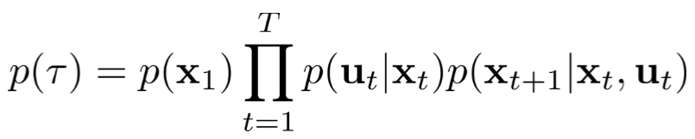

* Again this means bounding the KL divergence of old and new trajectory probability
* Similar to trust regions for policy gradient methods
* One gets:

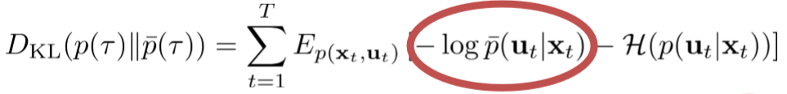

* The constrained problem we want to solve is thus:

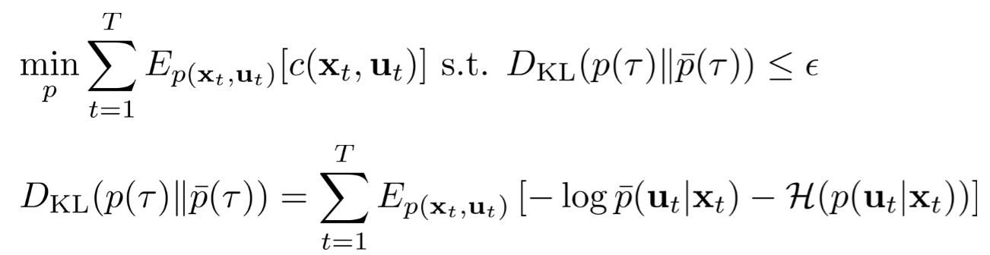

* .. for which the Lagrangian is:

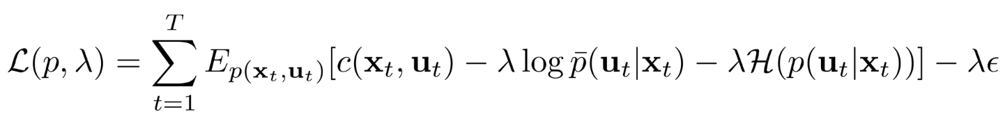

* This is solved by Dual Gradient Descent with iterative LQR, namely

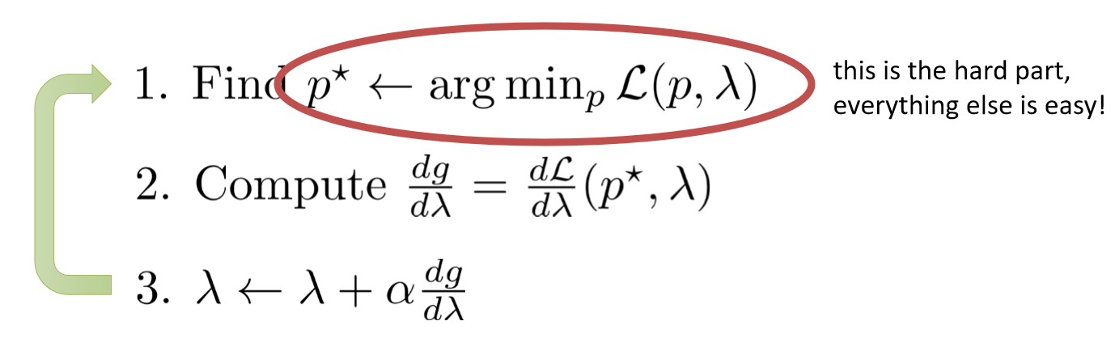

* For step 1, just use LQR with 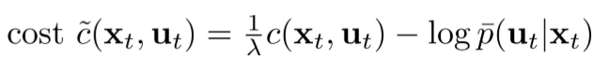:

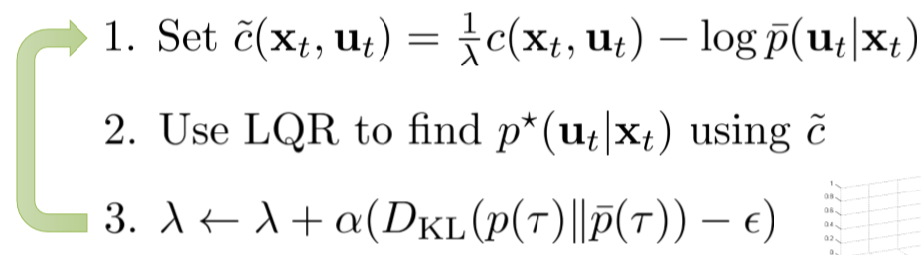

* Remarks:
  + Bounding KL-divergences between two policies or controllers, whether linear-Gaussian or more complex (e.g. neural networks) is really useful
  + Bounding KL-divergence between policies is equivalent to bounding KL-divergences between trajectory distributions

**Advanced Model-Based Reinforcement Learning (Week 12)**

* Topics
  + Managing overfitting in model-based RL
    - What is the problem?
    - How do we represent uncertainty?
  + Model-based RL with images
    - The POMDP model for model-based RL
    - Learning encodings
    - Learning dynamics-aware encoding
* Empirical tests (see Nagabandi et al, ICRA 2018) show that model free RL much outperforms model-based RL (and that the latter can be used to initialize the former, with big performance improvement)

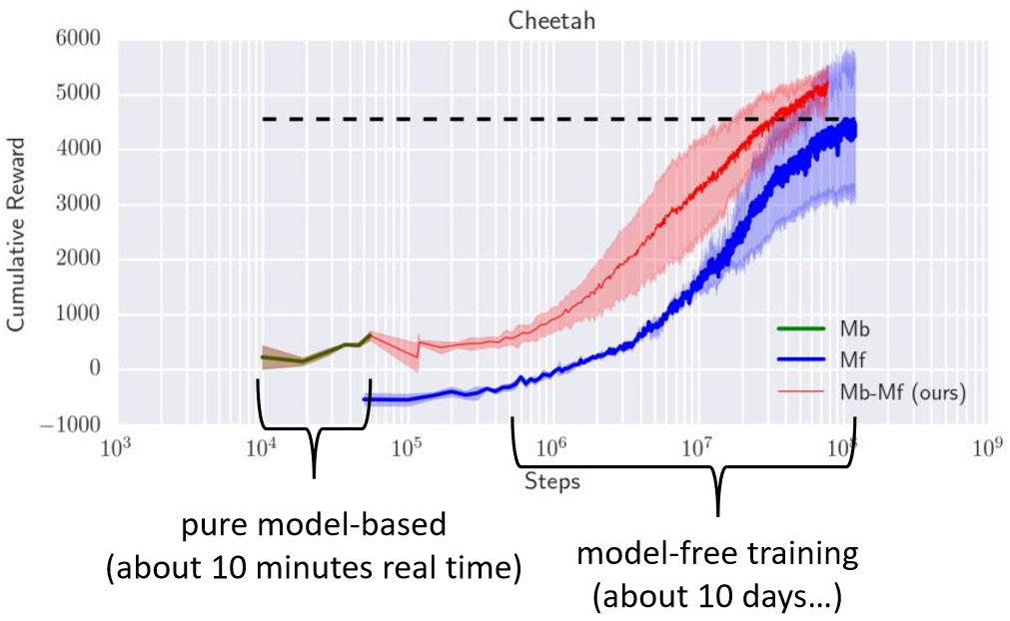

* The issue can be tackled by modelling the uncertainty of the predictions, for instance using a Gaussian Process (GP) framework (cfr. Deisenroth et al, “Learning to control a low-cost manipulator ..”)

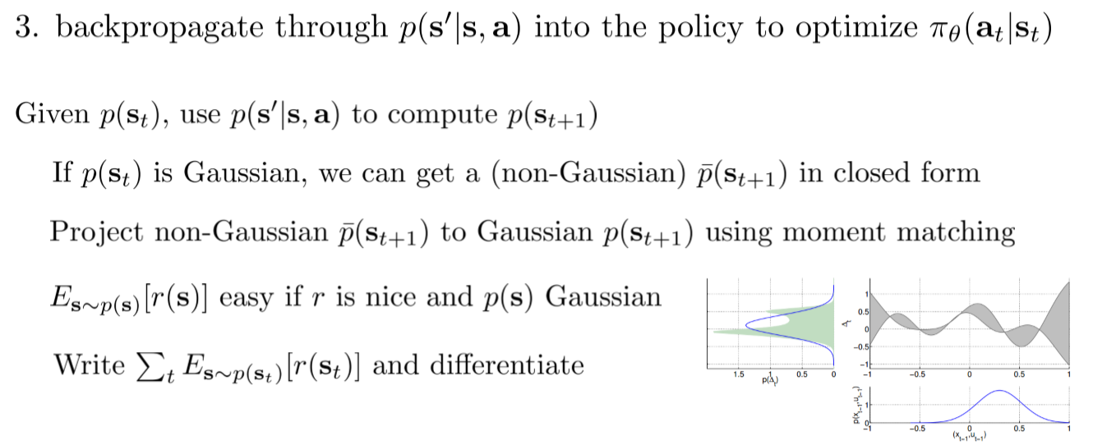 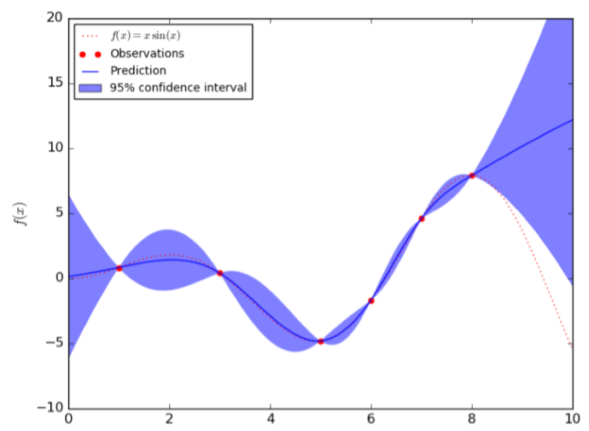(RL)

* The intuition is that at step 3 of model-based v1.5, we only take actions we think will get high *expected* reward, w.r.t. the uncertain dynamics
  + This avoids ‘exploiting’ the model
  + The model will then adapt and get better
* How good a representative is the expectation, rather than the lower or upper bounds??
* Also, to get better we need to explore
* Uncertainty-aware models:
  + Simply use the entropy of the distribution p(s) of the state (aleatoric uncertainty)
    - This though does not account of epistemic uncertainty on the model itself
  + Estimate model uncertainty: can we estimate p(θ|D)?
    - We can then predict according to: $$\int{p\left(s_{t+1} | s_{t},a_{t},θ\right)}p(θ|D)dθ$$
* One option is to use a Bayesian neural net, with p(θ|D) factorized into the θi s
* This is related to variational inference: see Blundell et al., Weight Uncertainty in Neural Networks; Gal et al., Concrete Dropout
* Bootstrap ensembles: Train multiple models (e.g. a deep net) and see if they agree
  + need to generate “independent” datasets Di from D, to get “independent” models
  + θi is trained from Di , sampled with replacement from D
* Crude approximation, number of models is usually small, but it works (?)
* How to plan with uncertainty: for a candidate action sequence **a**1…**a**T
  1. Sample the model θ;
  2. use the model to produce the sequence of states;
  3. compute the total reward;
  4. average the total reward of the samples;
  5. pick the sequence of actions with the highest averaged reward
* More sophisticated option: use (RL) method above to project p(**s**t) onto space of Gaussians and differentiate the total expected reward
* Further readings
  + Deisenroth et al. PILCO: A Model-Based and Data-Efficient Approach to Policy Search
  + Chua et al. Deep Reinforcement Learning in a Handful of Trials using Probabilistic Dynamics Models
  + Feinberg et al. Model-Based Value Expansion for Efficient Model-Free Reinforcement Learning
  + Buckman et al. Sample-Efficient Reinforcement Learning with Stochastic Ensemble Value Expansion

**Model-based RL with images**

* Requires involving POMDP which separate the state from the observable quantities
* Learning needs to happen in the latent space: key is learning the embedding $g\left(o_{t}\right)=x_{t}$
* Learning can then be either model-based or model-free
* Algorithm (from “Autonomous reinforcement learning on raw visual input data in a real world application”):
  1. Collect data with exploratory policy
  2. Learn low-dimensional embedding of image (e.g. using deep autoencoder)
  3. Run q-learning with function approximation with embedding
* Pros: learns visual skill very efficiently
* Cons: autoencoder might not recover the right representation; not necessarily suitable for model-based methods
* Model-based example: “Deep spatial autoencoders for visuomotor learning”

1. Collect data with exploratory policy
2. Learn smooth, structured embedding of image (? *Unclear, need to read paper*)
3. Learn locally-linear model with embedding
4. Run iLQG with local models to learn to reach goal image

* As the method does not learn states, it needs a reward
* Model based example: “Embed to control: A locally linear latent dynamics model for control from raw images”
  1. Collect data
  2. Learn embedding of image & dynamics model (jointly)
  3. Run iLQG to learn to reach image of goal
* Other approach: learn directly in observation space (see SOLAR paper)
* Directly learns $p(o_{t+1}|o_{t},a_{t})$

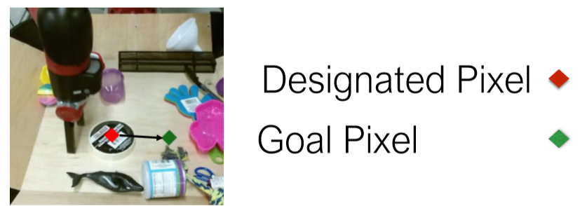

* An option is to predict alternative qualities (e.g. will I grasp? Will I collide?)

**Model-Based RL and Policy Learning (Week 13)**

* Questions
  + Last time: learning models of system dynamics and using optimal control (trajectory optimisation) to choose actions
  + What if we want a policy?
    - Much quicker to evaluate actions at runtime
    - Potentially better generalization
  + Can we just back-propagate into the policy?
* Topics
  + Back-propagating into a policy with learned models
  + This becomes equivalent to imitating optimal control (i.e., supervised learning of policy parameters from optimal trajectories)
  + The guided policy search algorithm
  + Imitating optimal control with Dagger
  + Model-based vs. model-free RL tradeoffs
* We saw in model-based RL version 2.0 that we can back-propagate directly into the policy

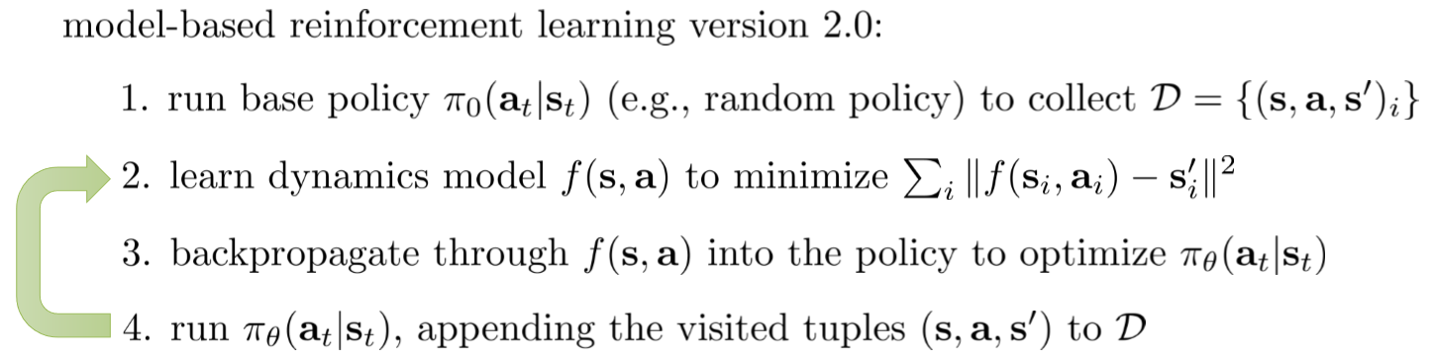

* Problem with this:

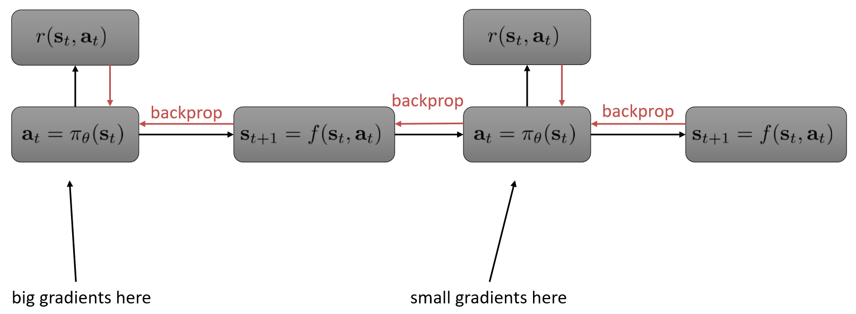

* Similar problems to training long RNNs: vanishing and exploding gradients
* Unlike LSTM, we can’t just “choose” a simple dynamics, dynamics are chosen by nature (i.e, dynamics is an input to the backprop algorithm which comes from step 2)
* Collocation methods (which optimize over both actions and states) can help

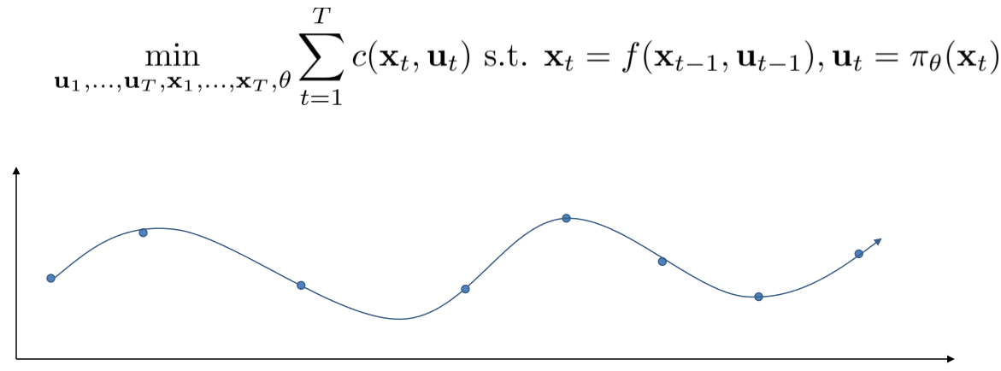

* A simpler approach is to decompose the above problem into trajectory optimization + constraints:

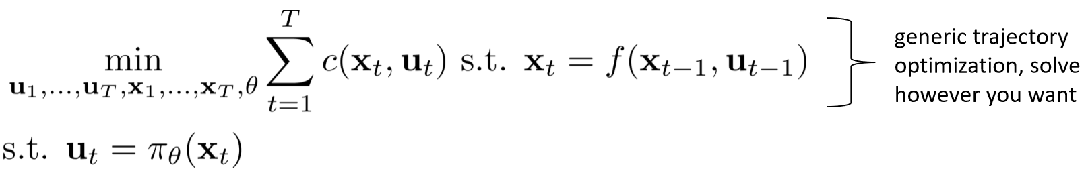

* How can we impose constraints on trajectory optimization?
* Can be done by tweaking dual gradient descent (DGD) with an augmented Laplacian
  + $\min_{x}{f\left(x\right)}s.t.C\left(x\right)=0$; augmented Laplacian: $\overline{L}\left(x,λ\right)=f\left(x\right)+λC\left(x\right)+ρ{\left\|C\left(x\right)\right\|}^{2}$
  + Algorithm:

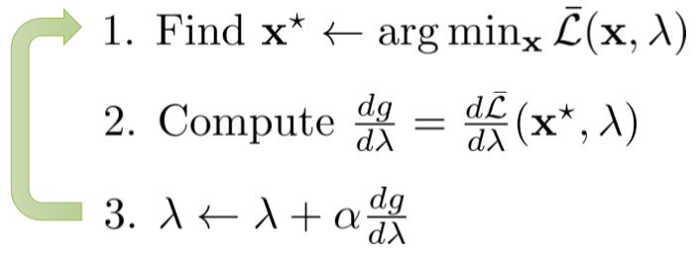

* Features
  + Still converges to correct solution
  + When far from solution, quadratic term tends to improve stability
  + Closely related to alternating direction method of multipliers (ADMM)
* In our case (trajectory optimisation with constraints) we get (guided policy search method):

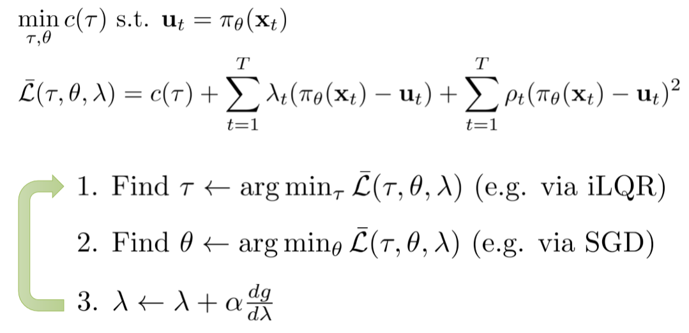

* Observations on guided policy search:
  + Can be interpreted as constrained trajectory optimization method
  + Can be interpreted as imitation of an optimal control expert, since step 2 is supervised learning (the ‘target’ trajectories τ are given)
  + The optimal control “teacher” adapts to the learner (i.e., the objective function is a function of the parameters θ of the current policy), and avoids actions that the learner πθ cannot mimic
* General guided policy search

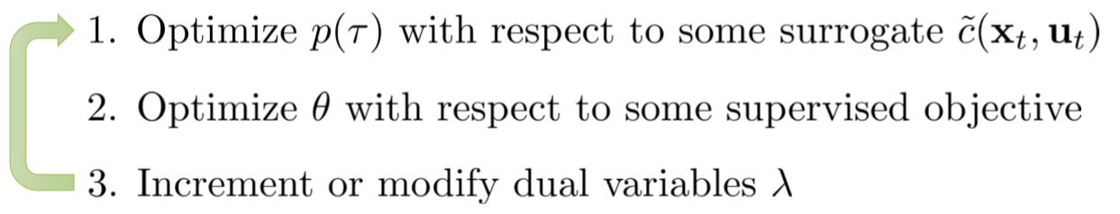

* We need to choose:
  + The form of p(τ) or τ (in the deterministic case)
  + The optimisation method for them
  + The surrogate
  + The supervised objective for πθ
* We can also learn with multiple trajectories

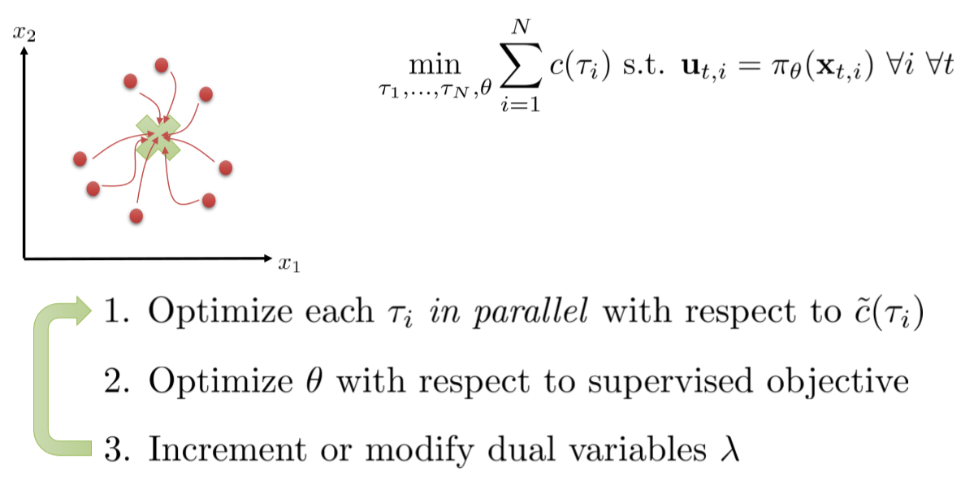

* Case study: learning locomotion skills (“Interactive control of diverse complex characters with neural networks”, NIPS 2015)

**Imitating optimal control with Dagger**

* The PLATO algorithm

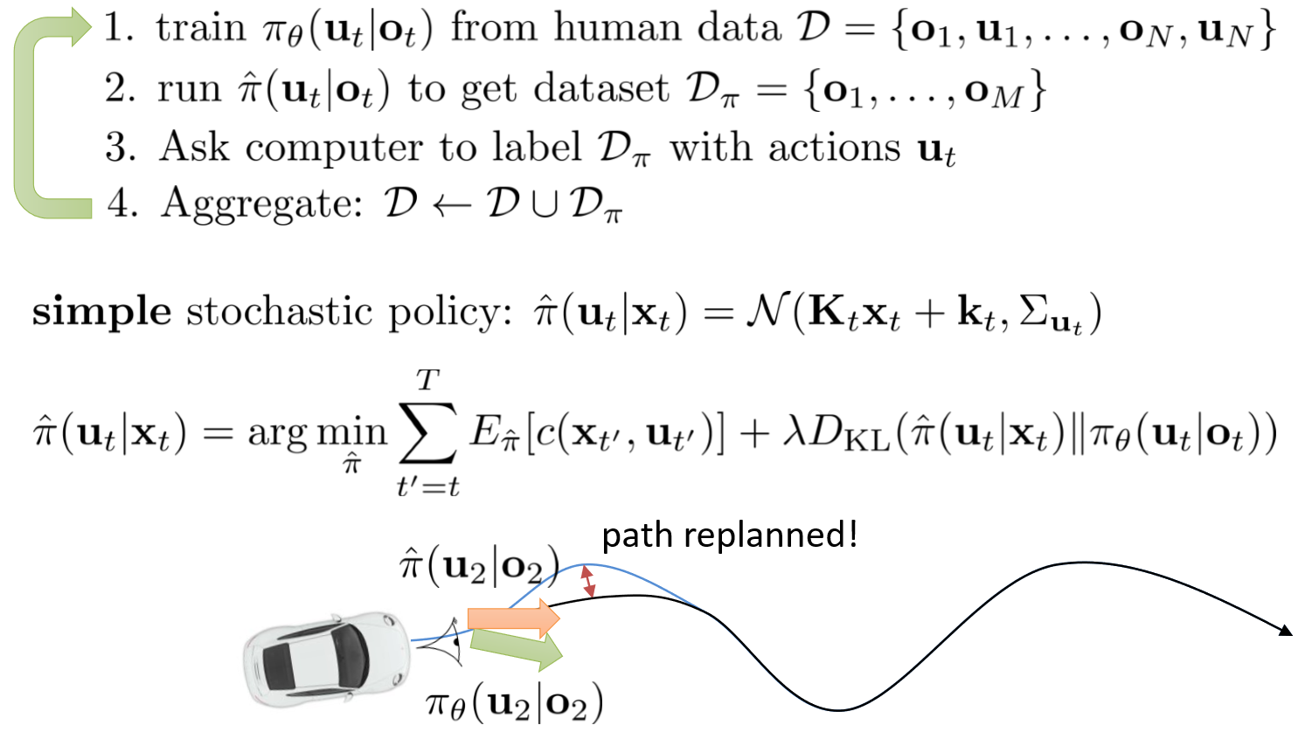

* Dagger vs GPs
  + DAgger does not require an adaptive expert: Any expert will do, so long as states from learned policy can be labeled
  + Assumes it is possible to match expert’s behavior up to *bounded* loss: this is not always possible
  + GPs adapt the “expert” behavior to the ability of the policy (expert will change in time)
* Why imitate at all?
  + Relatively stable and easy to use
    - Supervised learning works very well
    - Control/planning (usually) works very well
    - The combination of the two (usually) works very well
  + Input remapping trick: can exploit availability of additional information at training time to learn policy from raw observations
  + Overcomes optimization challenges of backpropagating into policy directly
  + Usually sample-efficient and viable for real physical systems
* Model-free optimization can be used even when we have a model: sometimes better than using gradients (see “PIPP: Flexible Model-Based Policy Search Robust to the Curse of Chaos”)
* Dyna is an example of online Q-learning algorithm that performs model-free RL with a model

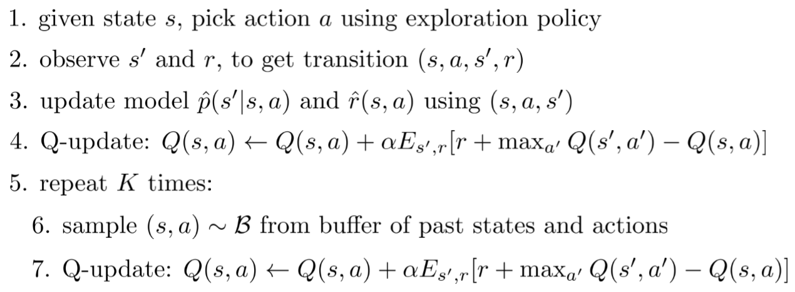

* General dyna-style recipe for model-based RL

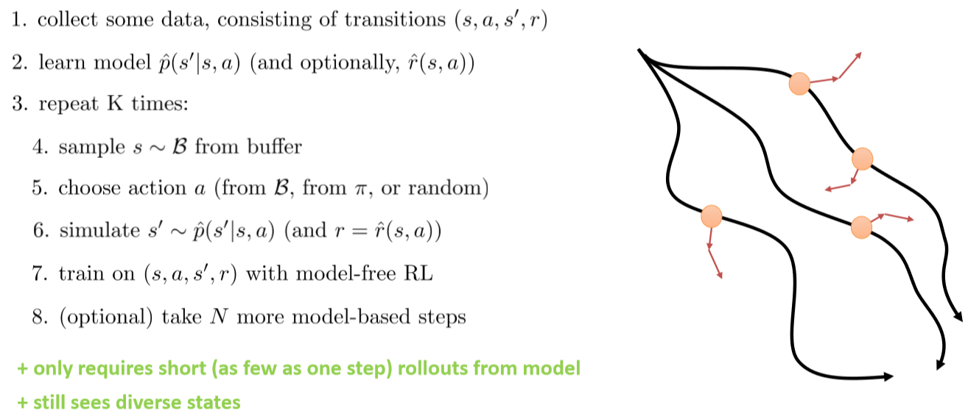

* The bottom line is: I learn a transition model from the data only to use it to generate sample transition I can do model-free RL upon
* Examples: “Continuous deep Q-learning with model-based acceleration” (‘16) and “Model-based value expansion” (‘18)
* Model-based RL algorithms summary
  + Learn model and plan (without policy)
    - Iteratively collect more data to overcome distribution mismatch
    - Re-plan every time step (MPC) to mitigate small model errors
  + Learn policy
    - Back-propagate into policy (e.g., PILCO) – simple but potentially unstable
    - Imitate optimal control in a constrained optimization framework (e.g., GPs)
    - Imitate optimal control via DAgger-like process (e.g., PLATO)
    - Use model-free algorithm with a (dynamics) model (Dyna, etc.)
* Limitations of model-based RL
  + Need some kind of model
    - Not always available, Sometimes harder to learn than the policy
  + Learning the model takes time & data
  + Requires additional assumptions of some kind
    - Linearizability/continuity
    - Ability to reset the system (for local linear models)
    - Smoothness (for GP-style global models)
* Which algorithms to use? That depends on the problem at hand

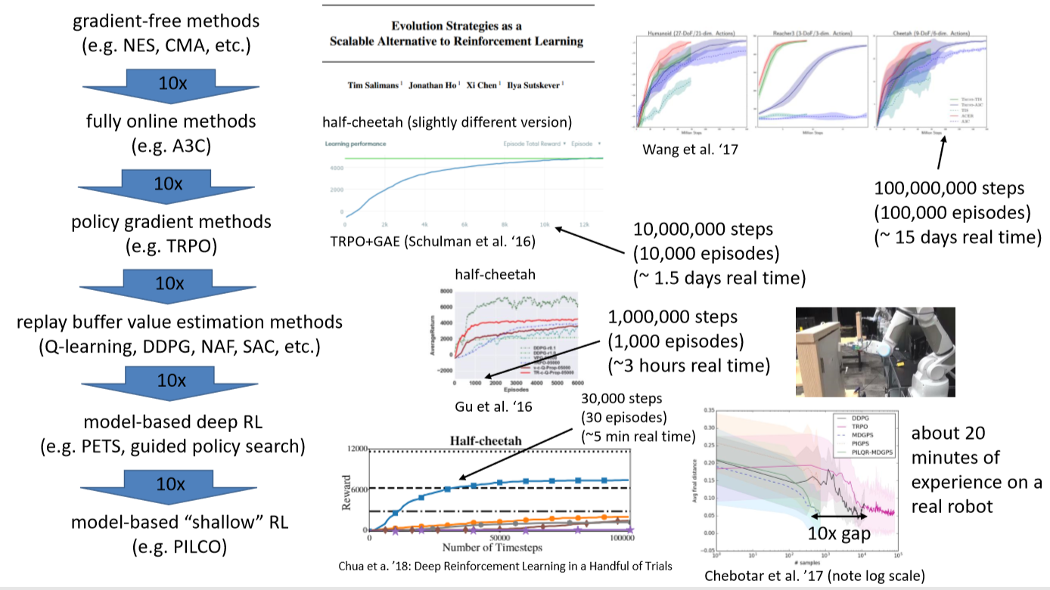

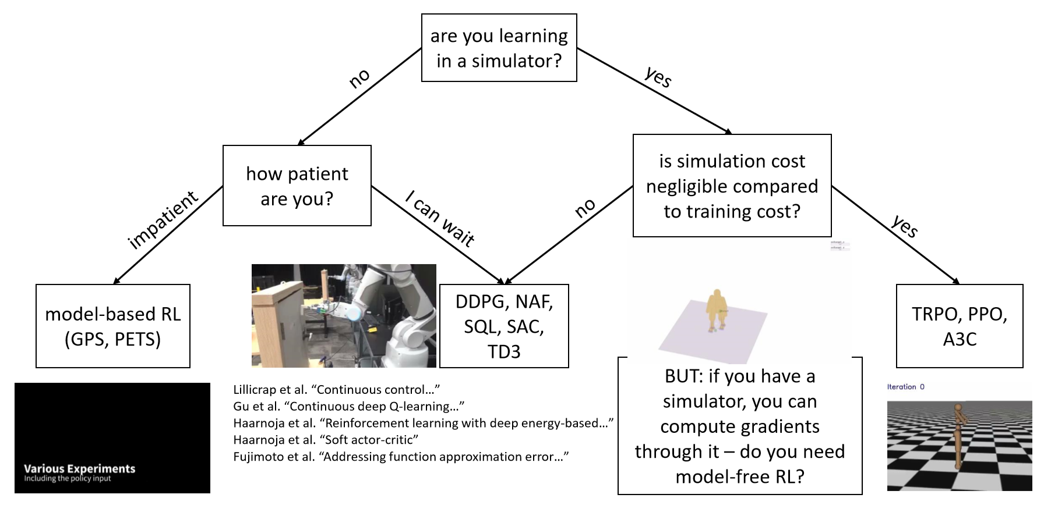

**Variational Inference and Generative Models (Week 14)**

* Topics
  + Probabilistic latent variable models
  + Variational inference
  + Amortized variational inference
  + Generative models, variational autoencoders

**Latent variable models**

* Actually, POMDPs are latent variable models, i.e. they model $p\left(y | x\right)=\int{p(y|x,z)p(z)}$
* Latent variable models are used to model **multimodal policies**

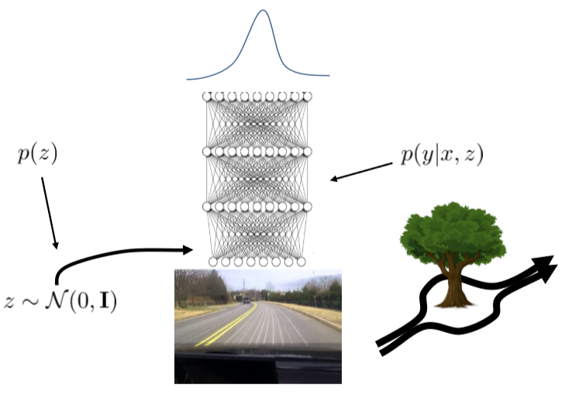

* Here p(z) is a simple PDF (e.g. Gaussian), p(y|x,z) is modelled by a network and p(y|x) is complex (multimodal)
* Generative models and variational inference are used to model human behavior, or for explanation
* Latent models are trained by maximizing the (log)-likelihood, usually intractable

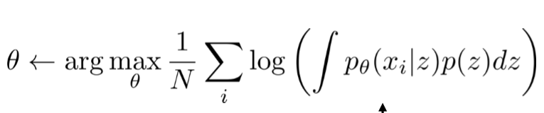

* Alternative: **maximising the expected log-likelihood**

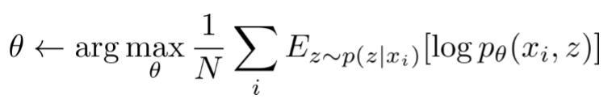

* We need to calculate p(z|xi)

**The variational approximation**

* The idea is to find a bound to log p(xi)
* Step1: 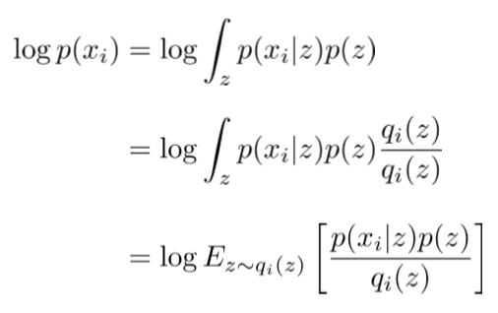
* Now log p(xi) is reduced to an expectation in an arbitrary auxiliary variable qi
* Step 2: use as q_i a Gaussian
* Step 3: using Jensen’s inequality log E[y] ≥ E[log y], log p(xi) becomes

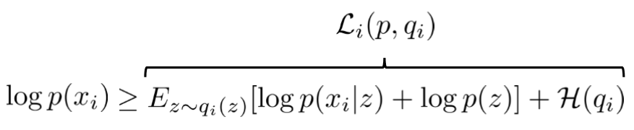

* where H(qi) is the entropy of qi
* The intuition is that qi should approximate p(z|xi), in the sense of the Kullback-Leibler (KL) divergence



* Indeed, DKL(qi(x)||p(z|xi)) = - Li(p,qi) + log p(xi)
* Hence  and Li(p,q_i) is a lower bound to log p(xi)
* Also, minimizing Li w.r.t. qi minimizes the KL divergence
* So, the model can be trained using Li:

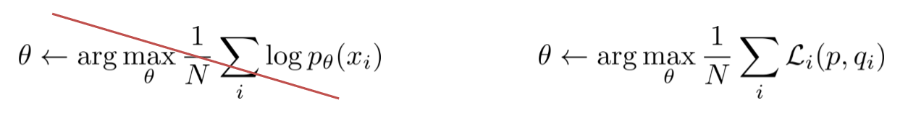

* For instance, if we assume qi is N(μi,σi) we compute the gradients of Li w.r.t. μi and σi and do gradient ascent on them
* Algorithm

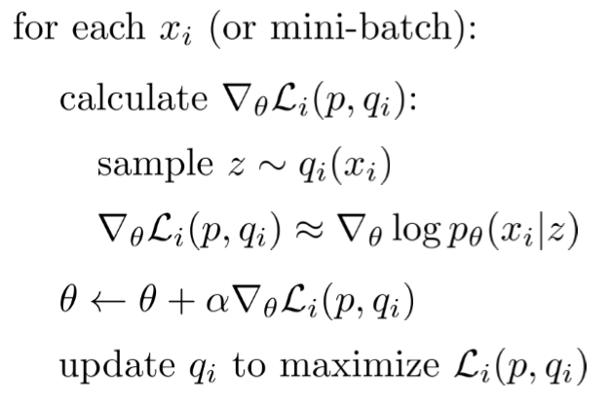

* Two things: L is a function of p(xi|z)
* We can learn a network with input x and output qθ(z|x)
* Bottom line: we need to train two networks with two sets of parameters, θ and φ:

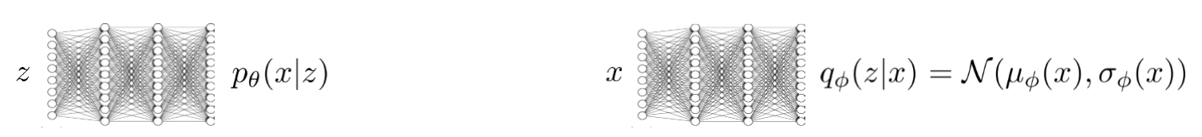

**Amortized variational inference**

* How do we calculate the gradient of L w.r.t. φ?
* If qφ is a Gaussian we can look up the entropy of a Gaussian, and then

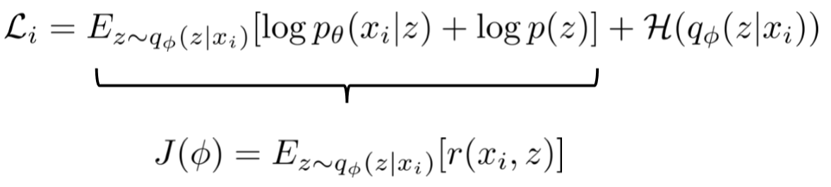

and we can just use *policy gradient* on J(φ):

$$∇_{ϕ}J(ϕ)∝\sum_{j}{∇_{ϕ}\log{q_{ϕ}\left(z_{j} | x_{i}\right)}r(x_{i},z_{j})}$$

* A better way is provided by the *reparameterisation trick*: $z=μ_{ϕ}\left(x\right)+ϵσ_{ϕ}(x)$
* To estimate ∇φ J(φ) one then samples $ϵ_{1},…,ϵ_{M}$ from N(0,1) and gets

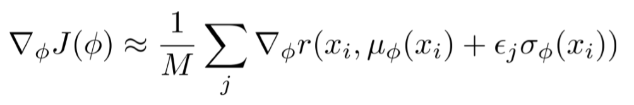

* Tensorflow does that for you
* Reparameterisation versus policy gradient:
  + Policy gradient can handle both discrete and continuous latent variables
  + High variance, requires multiple samples and small learning rates
  + Reparameterisation works only with continuous latent variables, simple to implement and with low variance

**Variational autoencoders**

* The *variational autoencoder* is the cascade of the two networks described above, under the reparameterisation trick

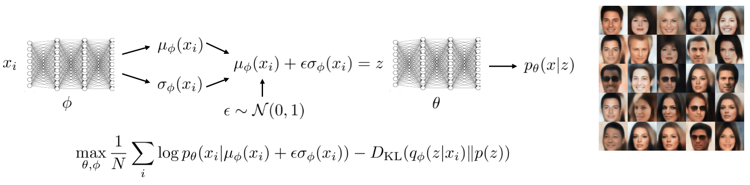

* Conditional model:



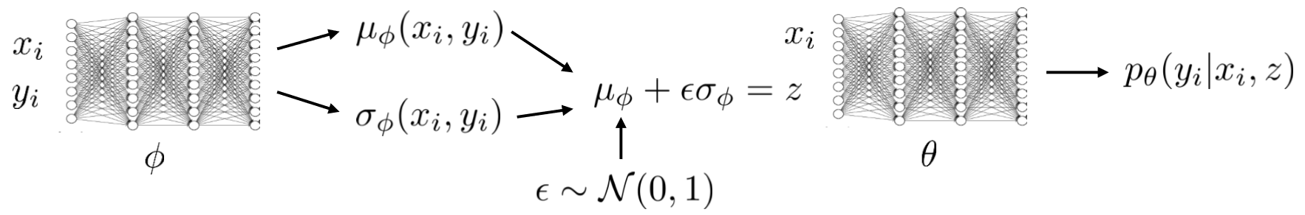

* Example papers:
  + Embed to control: a locally linear latent dynamics model for control from raw images
    - Learns embedding of image and dynamics model jointly
    - Runs iLQG for learn to reach image of goal
    - Uses a type of variational autoencoder in which the latent state is decomposed in time thanks to the Markov property
  + SOLAR: deep structured latent representations for model-based reinforcement learning

**Optimal control as an inference problem (Week 15)**

* Topics
  + Do reinforcement learning and optimal control provide a reasonable model of human behavior?
  + Optimal control, reinforcement learning and planning as probabilistic inference
  + How does this change our RL algorithms?
  + Week 16: how this is crucial for inverse reinforcement learning

**Optimal control as a model of human behavior**

* Can we explain human behavior as *an instance of optimal control* in which this is done

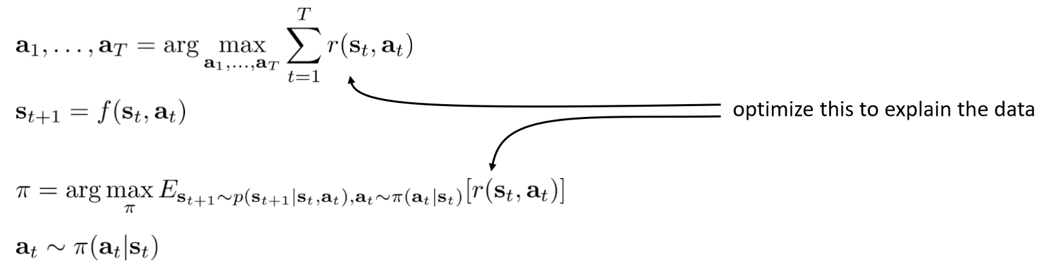

*under an appropriate reward function*?

* Problem is, human behavior is not in general optimal, but just good, and is aleatory

**Optimal control, reinforcement learning and planning as probabilistic inference**

* In alternative, one can assume a joint probability distribution of the sequence of states and action (a probabilistic model of behaviour), represented by a graphical model:

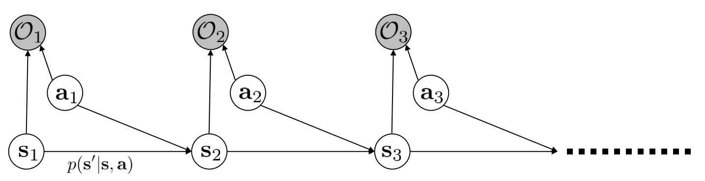

In which we assume that $p\left(O_{t} | s_{t},a_{t}\right)=e^{r(s_{t},a_{t})}$ [where is this assumption coming from?]

* This allows us to model suboptimal behavior (see inverse reinforcement learning), to apply inference algorithms to solve control and planning problems
* Also provides an explanation for why stochastic behavior might be preferred (?)
* Planning as inference:
  1. Compute backward messages $β_{t}\left(s_{t},a_{t}\right)=p\left(O_{1:T} | s_{t},a_{t}\right)$
  2. Compute policy $p(a_{t}|O_{1:T},s_{t})$
  3. Compute forward messages $α_{t}\left(s_{t}\right)=p(s_{t}|O_{1:t-1})$
* *1. Backward pass*: the form of the messages simplify under the assumption that all actions are uniformly likely a priori. For t=T-1 to 1:

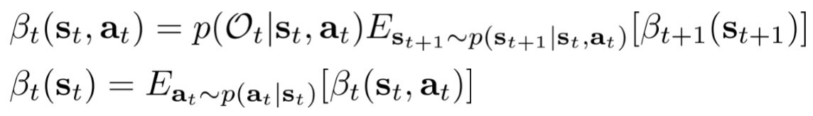(*1)

* Remark: if we set

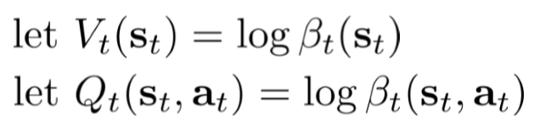 (*2)

We can notice that the log of $β_{t}$ is similar to a Q-function:

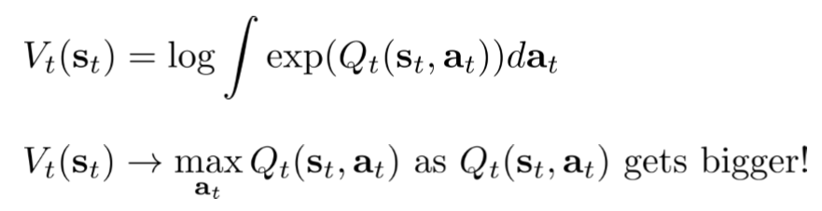

* Can we add an action prior to the mix?
* We can easily show that any action prior is absorbed by the reward function; so we can assume uniform prior without loss of generality
* *2. Policy computation*: under the probabilistic model simple application of the definition of conditional probability lead to:

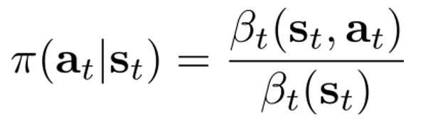

* In terms of value functions this is expressed as:



* Policy computation *with temperature*:



* Interpretation: ‘better’ actions are more probable, approaches greedy policy (pick the action that maximizing the reward at the next step only) as temperature decreases
* *3. Forward messaging.*
* Initialisation is done by $α_{1}\left(s_{1}\right)=p(s_{1})$ (usually known). Then

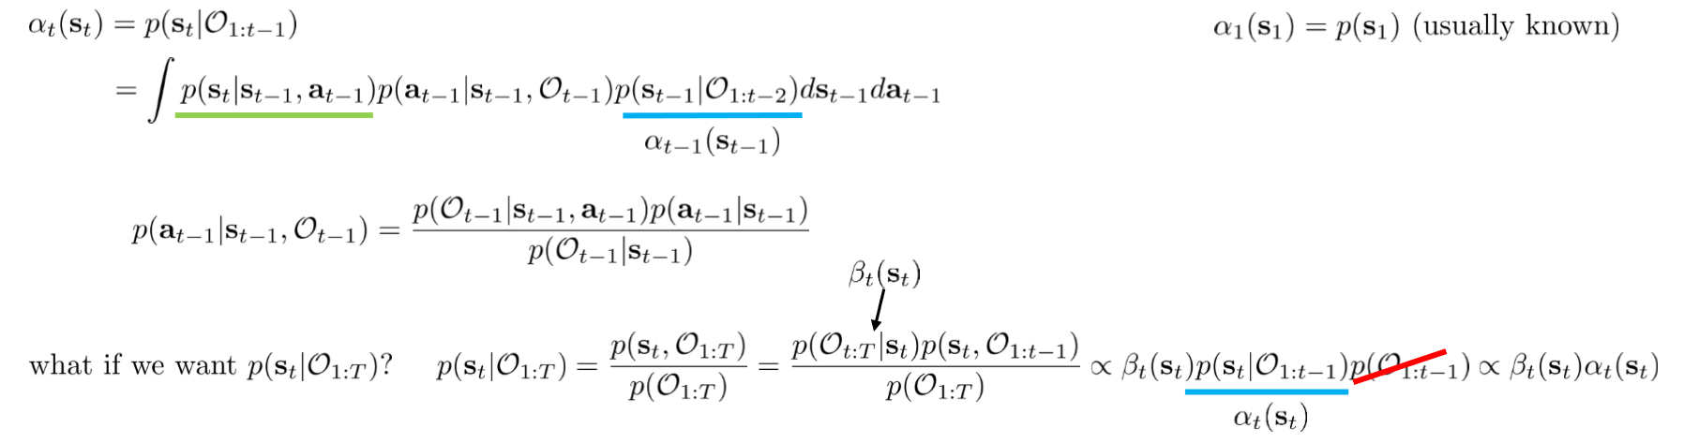

* Forward/backward message intersection:

1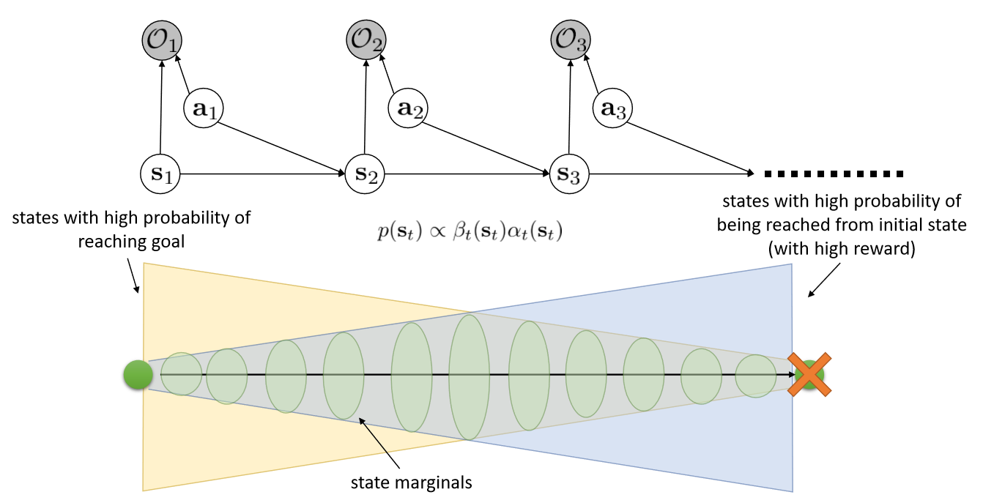

**Applying variational inference to address the optimism problem**

* Under (*1) and (*2) we have that

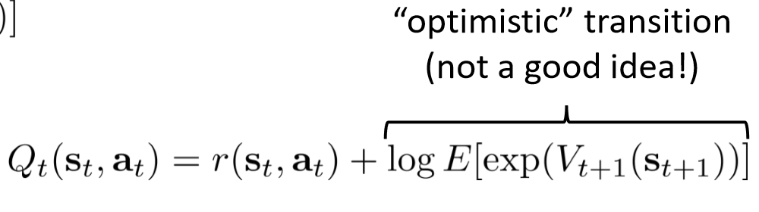

* [*why is this optimistic*?]
* We wish to find a distribution $q(s_{1:T},a_{1:T})$ which is close to $p(s_{1:T},a_{1:T}|O_{1:T})$ but has dynamics $p(s_{t+1}|{s_{t},a}_{t},)$, using variational inference

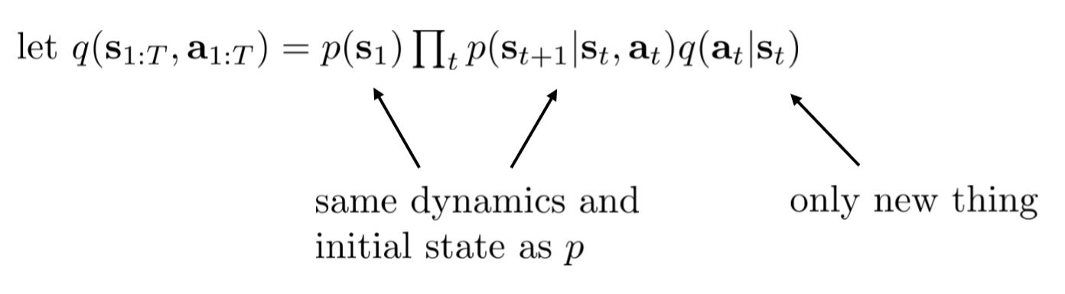

* If we use the notation ${x=O}_{1:T}$ and ${z=s}_{1:T},a_{1:T}$, the variational lower bound

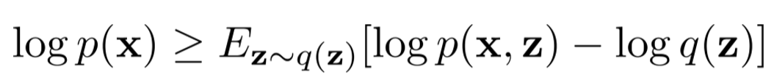 (*3)

becomes

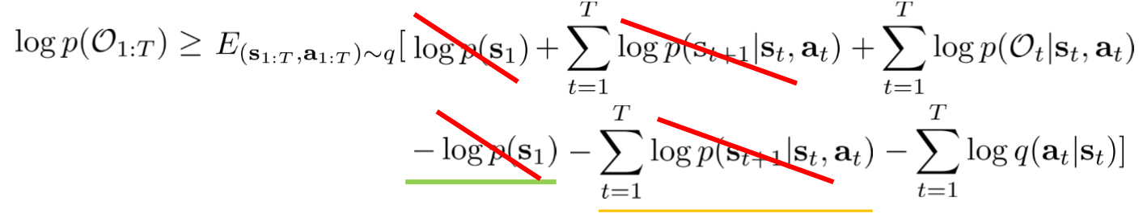

which is equal to:

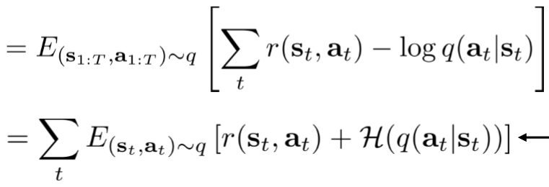

* This maximizes the reward *and* the action entropy!
* Optimising the variational lower bound (*3) leads, by solving for q(aT|sT), to the following expression for the probability of the sequence of actions given the sequence of states

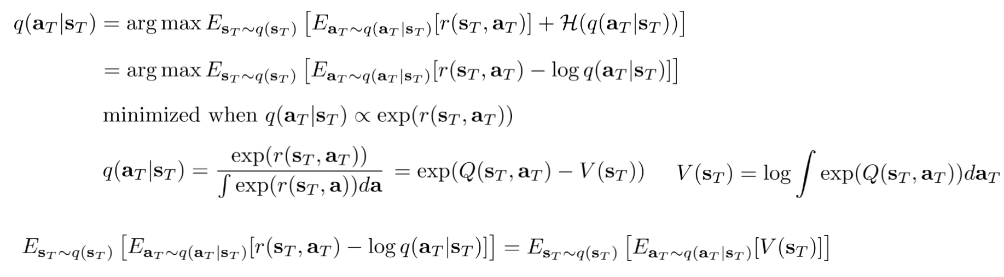

since this expression is minimized when the latter is exponential in the reward

* As for the probability of the current action given the current state we get:

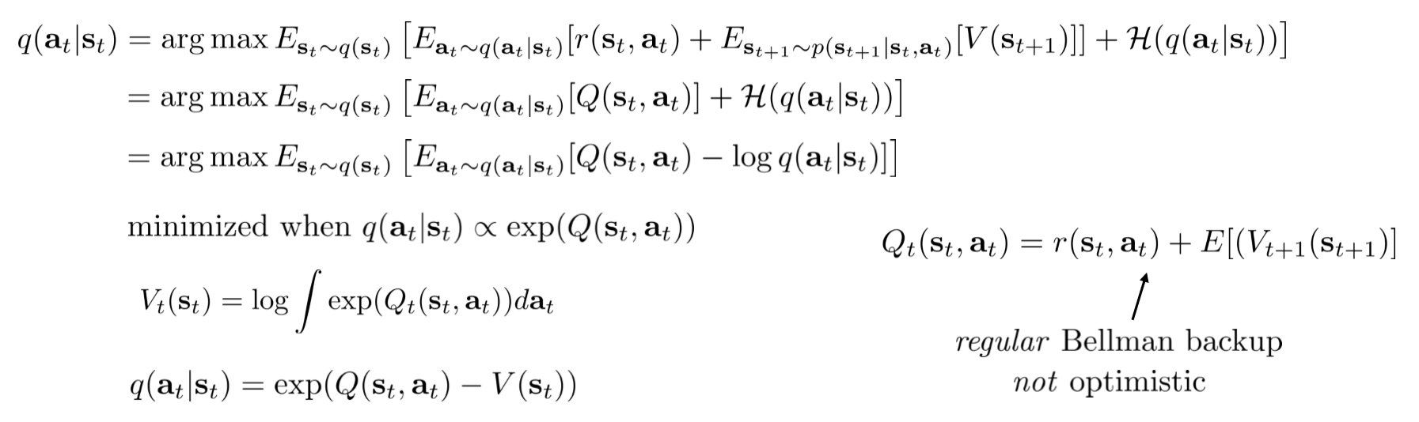

that it turns out to be exponential in the Q-function

* Summarising, the variational version of the backward pass is:

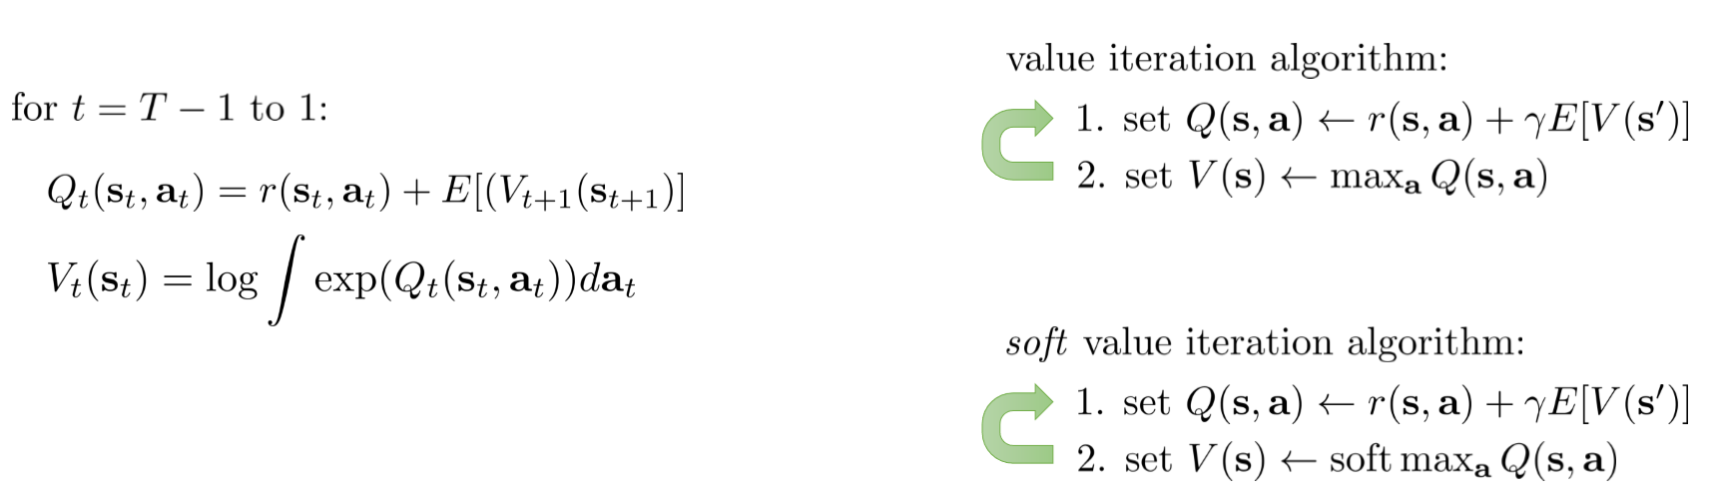

* Variants:

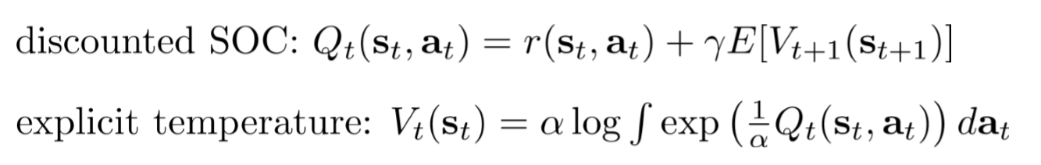

**Algorithms under soft optimality**

* Q-learning with soft optimality

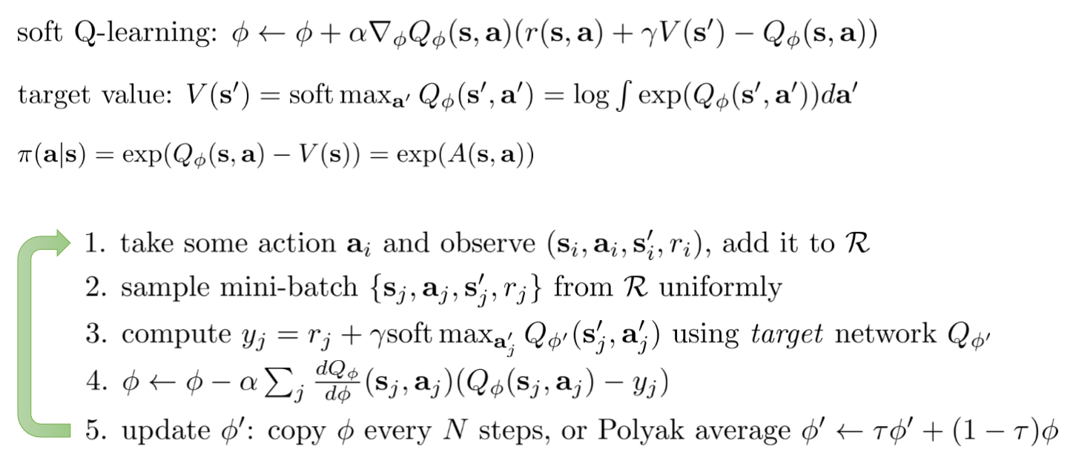

* Policy gradient with soft optimality
  + Often referred to ‘entropy regularised’ policy gradient
  + Intution: π(a|s) is proportional to exp(Q-V) when it minimizes their KL divergence, which in turn is equal to Eπ[Q] – H(π)

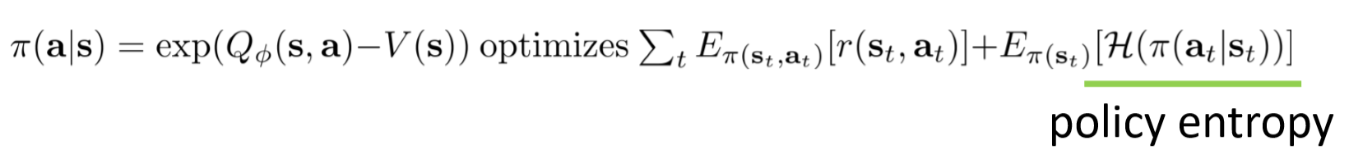

* + Closely related to soft Q-learning, see Haarnoja et al. ‘17 and Schulman et al. ‘17
* Benefits of soft optimality
  + Improve exploration and prevent entropy collapse
  + Easier to specialize (finetune) policies for more specific tasks
  + Principled approach to break ties
  + Better robustness (due to wider coverage of states)
  + Can reduce to hard optimality as reward magnitude increases
  + Good model for modeling human behavior [*I doubt that*]

**Reinforcement learning as inference on a graphical model**

* Reinforcement learning can be viewed as inference in a graphical model
  + Value function is a backward message
  + Maximize reward and entropy (the bigger the rewards, the less entropy matters)
  + Variational inference to remove optimism

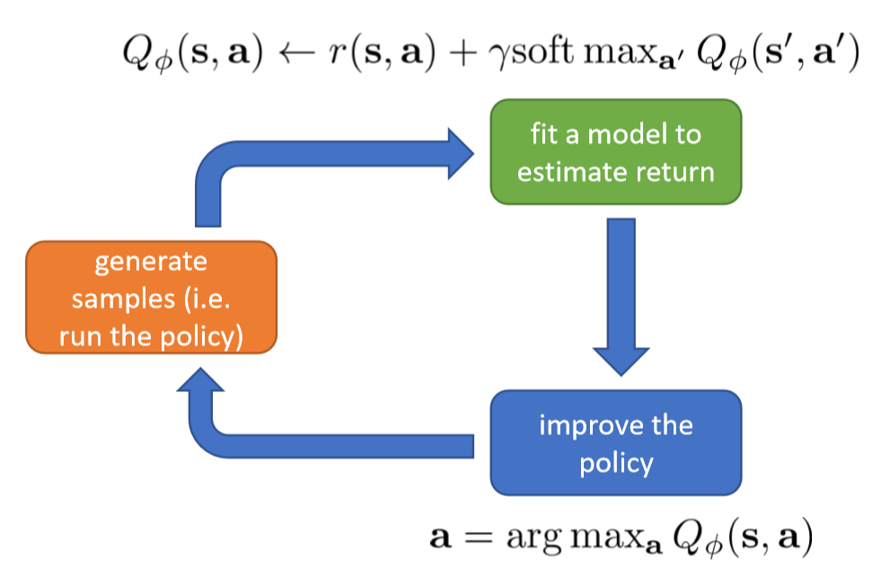

* Example: stochastic models for learning control (see ICML’17 paper below)
  + Uses soft Q-learning to model alternative behaviours
  + Stochastic energy-based policies provide pretraining
* Suggested readings
  + Linearly solvable Markov decision problems: one framework for reasoning about soft optimality
  + General duality between optimal control and estimation: primer on the equivalence between inference and control
  + Optimal control as a graphical model inference problem: frames control as an inference problem in a graphical model
  + Modeling interaction via the principle of maximal causal entropy: connection between soft optimality and maximum entropy modeling
  + On stochastic optimal control and reinforcement learning by approximate inference: temporal difference style algorithm with soft optimality
  + Reinforcement learning with deep energy based models: soft Q-learning algorithm, deep RL with continuous actions and soft optimality (ICML 2017)
  + Bridging the gap between value and policy based reinforcement learning (2017)
  + Equivalence between policy gradients and soft Q-learning
  + Soft Actor-Critic: Off-Policy Maximum Entropy Deep Reinforcement Learning with a Stochastic Actor (2018)
  + Reinforcement Learning and Control as Probabilistic Inference: Tutorial and Review (2018)

**Inverse Reinforcement Learning (Week 16)**

* Topics
  + To learn the reward function from observing an expert, and then use reinforcement learning to get a policy
  + The idea is to apply the approximate optimality model from last week, but now learn the reward!
  + Understand how probabilistic models of behavior can be used to derive inverse reinforcement learning algorithms
  + Understand a few practical inverse reinforcement learning algorithms
* Inverse reinforcement learning: infer reward function from roll-outs of expert policy (?)
* The alternative is to directly mimic the expert (*behavioural cloning*), i.e., look for the optimal expert policy π* directly; however
  + This does not necessarily capture the *salient* parts of the behavior
  + Can we reason about *what* the expert is trying to achieve instead?
* Challenges:
  + The problem can be underdefined
  + Evaluating a learned reward is difficult
  + Demonstrations may not be precisely optimal
* Forward vs inverse reinforcement learning

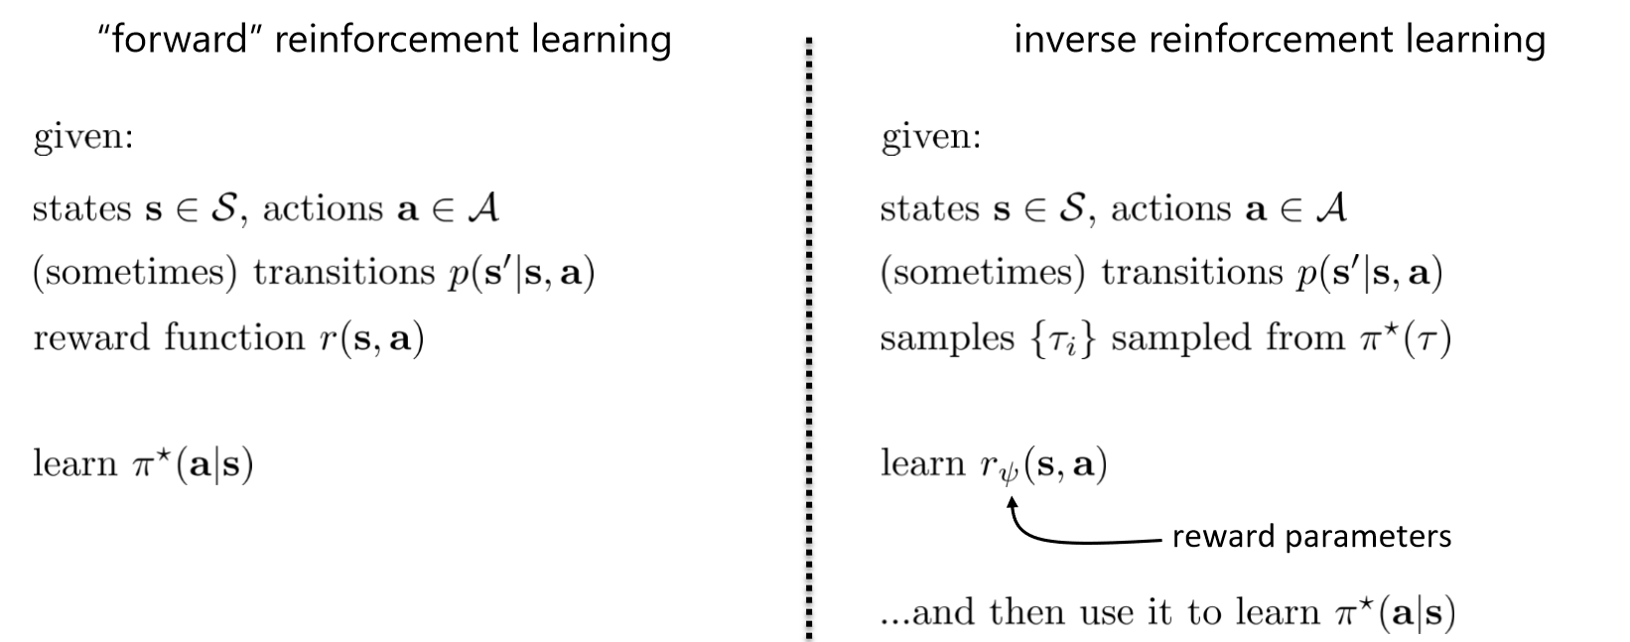

* Basic principle of IRL: find the r* that explains the expert’s behavior, such that

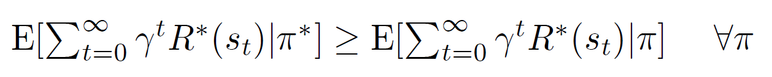 (1)

i.e., the expected return of the optimal (expert) policy is superior to the expected return of any other policy, under the reward function r*

* This is a convex feasibility problem but has many challenges:
  + R=0 is a solution, and in general there is ambiguity in the optimal reward function (many reward functions can satisfy this)
  + We do not usually observe the entire expert policy, but just a snippet
  + Assumes that the expert is indeed optimal in its behavior
  + Computationally, assumes that we can enumerate all policies
* What structure should we use for the reward function? A couple of alternatives:

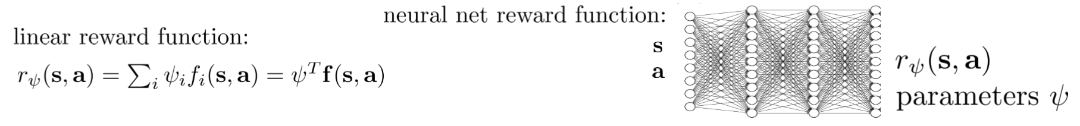

**Feature matching inverse reinforcement learning**

* Uses a reward function which is learning in a set of feature functions of state, action
* One option: pick the parameters ψ such that the expectation of the features matches that of the unknown optimal policy

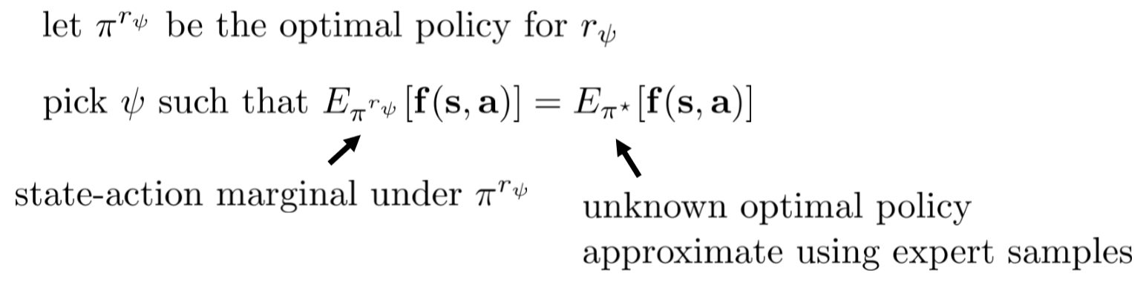

* From (1) it follows that

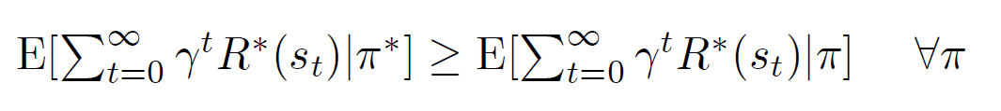

* Remarks:
  + Feature expectations can be readily estimated from sample trajectories
  + The number of expert demonstrations required scales with the number of features in the reward function
  + The number of expert demonstration required does not depend on the complexity of the expert’s optimal policy π*, or the size of the state space
* To solve the ambiguity challenge, we can apply the max margin principle, i.e., enforce that the optimal policy is better than any other by a margin *m* (under the optimal reward function)
* Maximum margin principle (Ratliff et al., 2006)

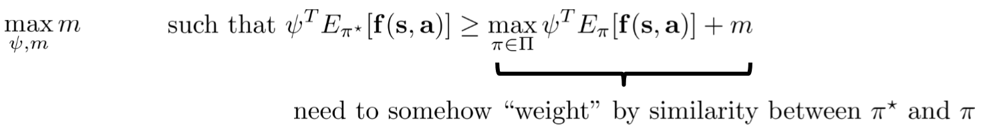

* Using the SVM ‘trick’, the problem becomes as follows

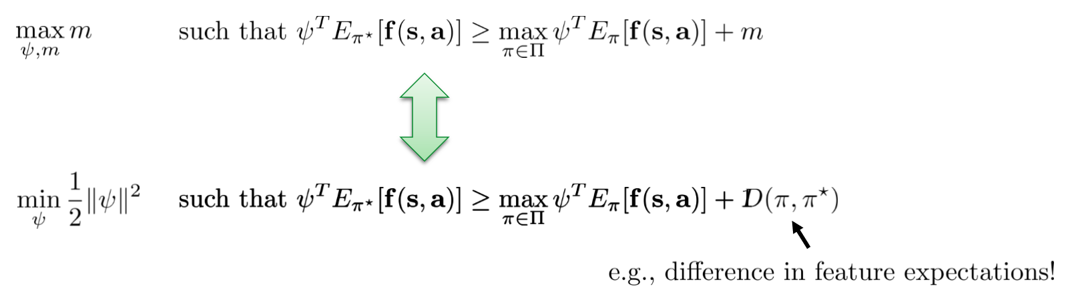

* Follows the ‘structured prediction’ max margin setting:

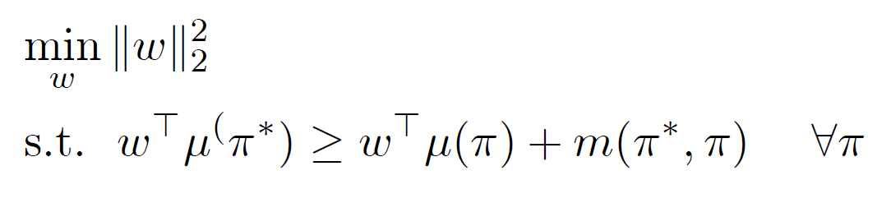

* The justification is that the margin should be larger for policies that are very different from π*
* For instance, $m(π^{*},π)$ could be the number of states in which π* was observed and in which the two policies disagree
* The further introduction of slack variables can cope with expert sub-optimality

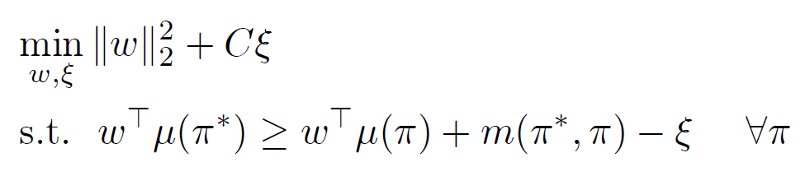

* Can be generalized to multiple expert policies (or the same with different initial states)

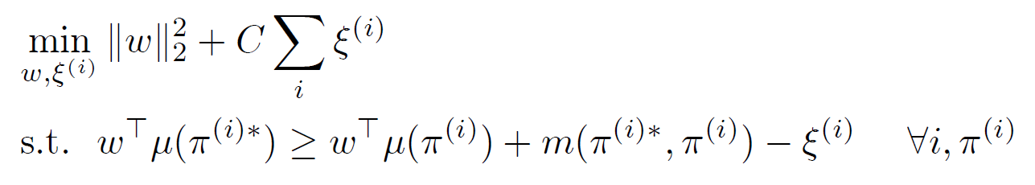

* Access to π* is also solved, for the difference is measured only over the observed interval
* However: very large number of constraints; Ratliff et al use subgradient methods
* Also
  + Maximizing the margin is a bit arbitrary [*quite a lot, actually*]
  + Messy constrained optimization problem – not great for deep learning!

**IRL with probabilistic graphical models**

* Assuming the usual graphical model of decision making, without any assumption of optimal behavior …

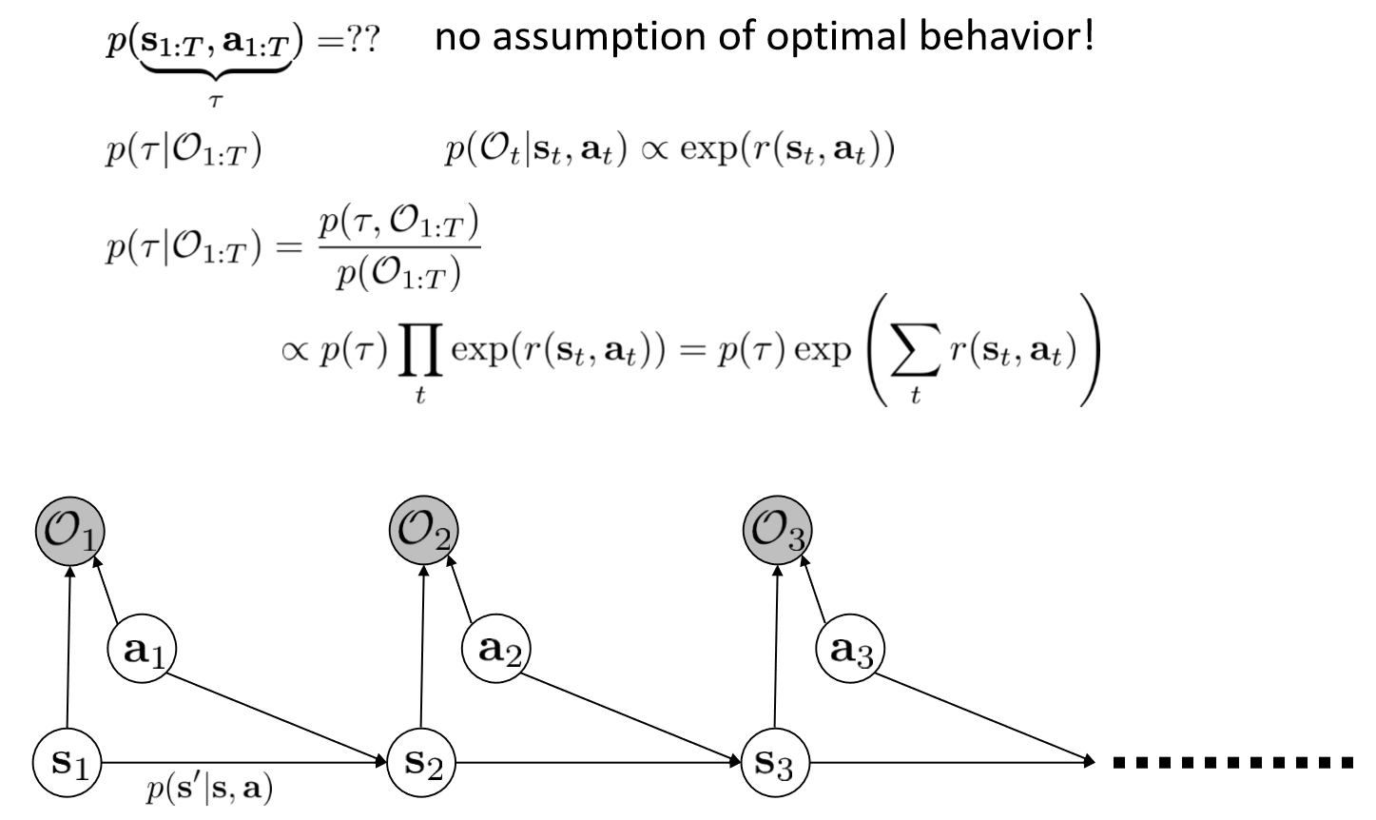

* … and given a number of samples ${\{τ}^{i}\}$ from π*, we can do maximum likelihood learning as follows:

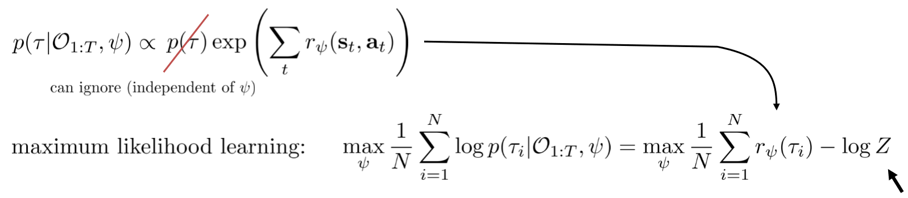

* The approach maximizes the likelihood of the samples of optimal behavior, based on the observations
* The difficult part is the ‘partition function’ Z
* That is tackled using a combination of estimates using expert samples, and soft optimal policy using the current reward (details on slides 11,12)
* The results can be expressed in terms of forward and backward messages α and β
* **The MaxEnt IRL algorithm**

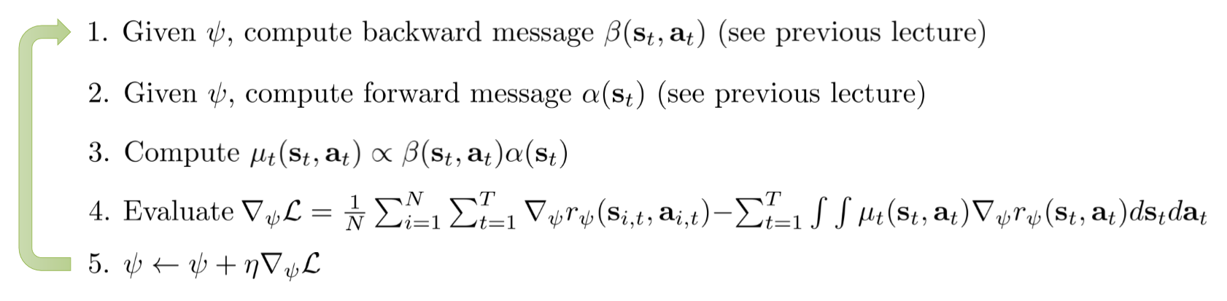

* It is called the MaxEnt algorithm, for when $r^{ψ}\left(s_{t},a_{t}\right)=ψ^{T}f(s_{t},a_{t})$ we can show that it optimizes

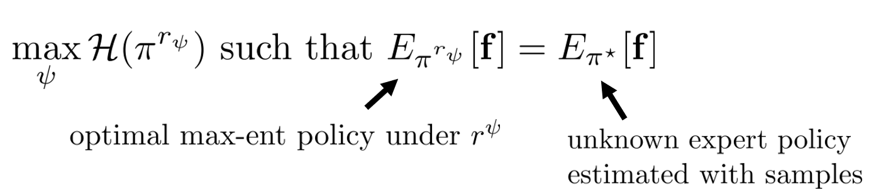

* The policy is as random as possible, while matching the features
* See Ziebart et al. AAAI 2008: Maximum Entropy Inverse Reinforcement Learning

**Large-scale IRL**

* MaxEnt IRL is a probabilistic framework for learning reward functions
* However, computing the gradient requires enumerating state-action visitations for all states and actions: this is only feasible for small, discrete spaces; amounts to dynamic programming
* Requirements for deep IRL:
  + Large and continuous state and action spaces
  + Effective learning under unknown dynamics
* Idea:
  1. Learn p(at|st, O1:T,ψ) using maxent RL
  2. Then use the above to sample {τj}
  3. Then we can approximate the gradient using samples

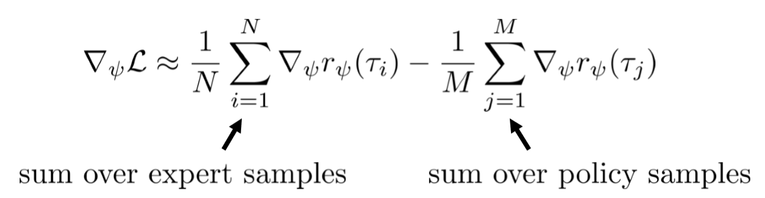

* To reduce bias in this estimator, one can use importance sampling

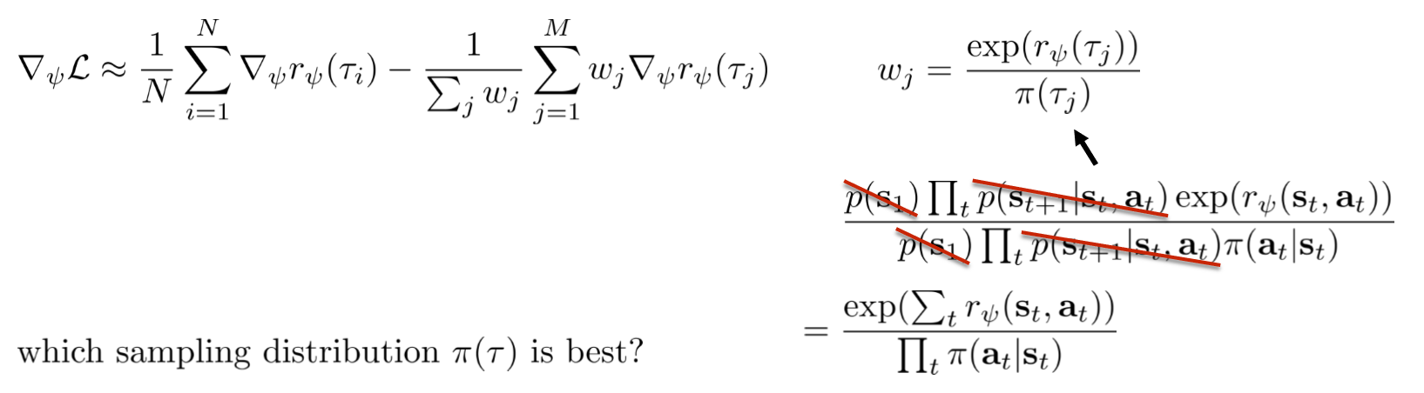

* Recall that



* In our case, the optimal π(τ) is therefore π(τ) ∝ exp(rψ(τ))
* This is the maxent optimal policy for rψ
* Each policy update w.r.t rψ brings us closer to the optimal distribution
* Guided cost-learning algorithm [Finn et al., ICML 16]

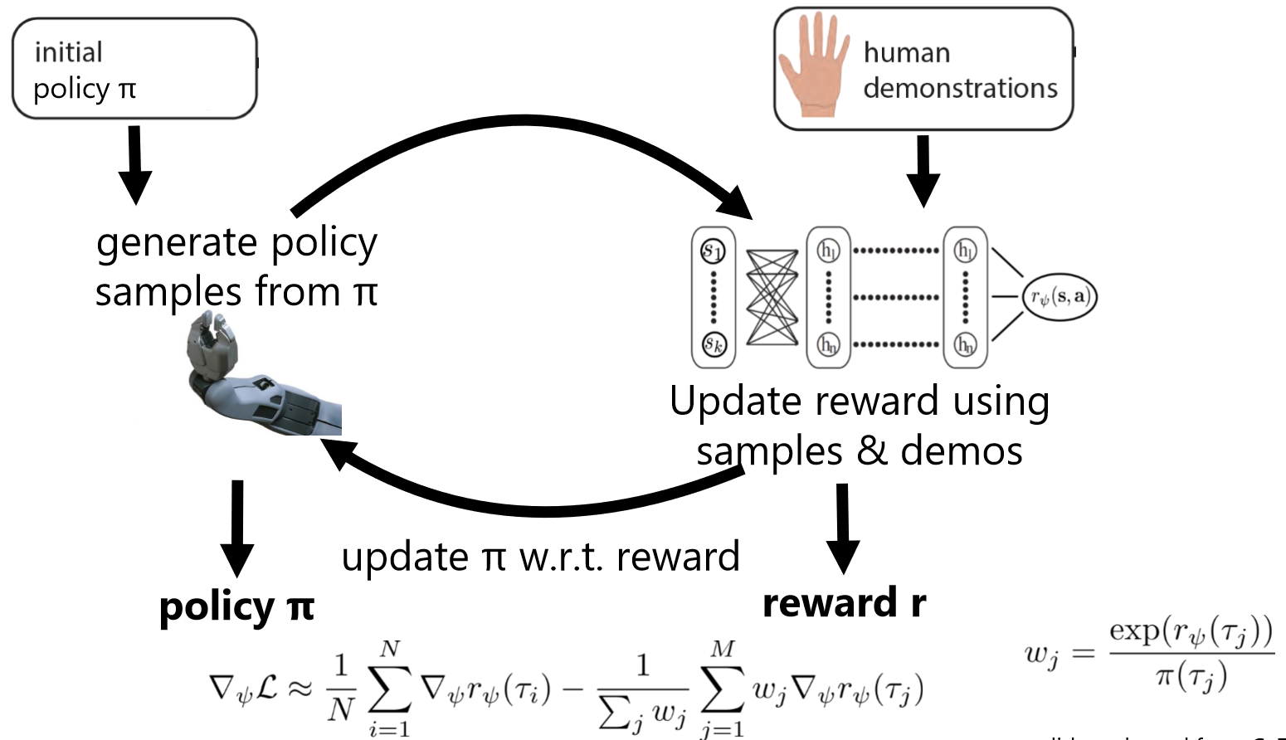

* Looks a bit like an adversarial setting, as we advance demonstrations are made more likely, samples less likely, but then policy changes to better mimic the demos

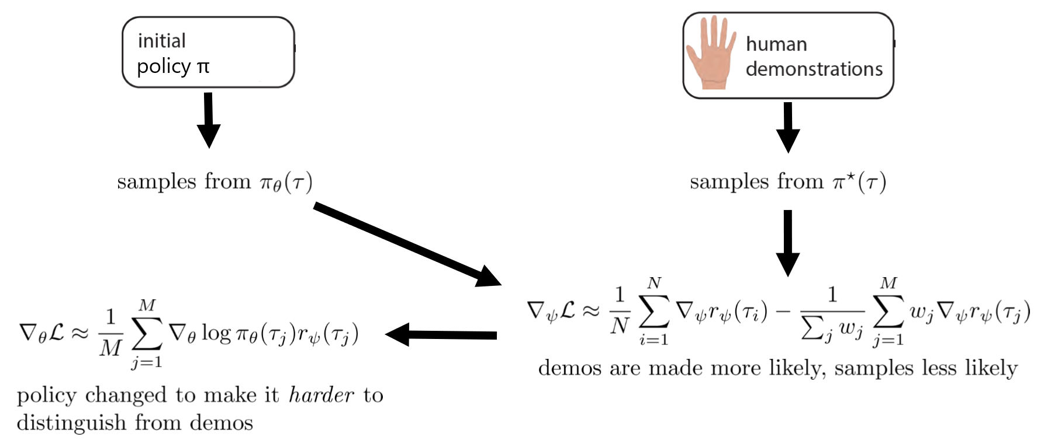

* Generative adversarial networks

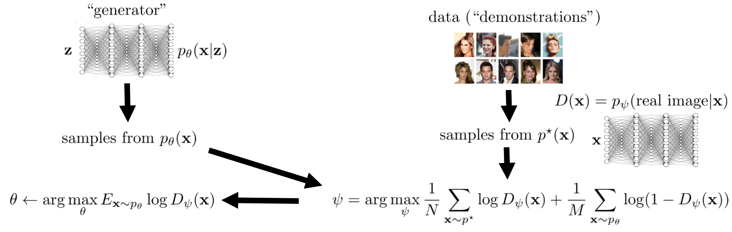

* Inverse RL can in fact be formulated as a GAN

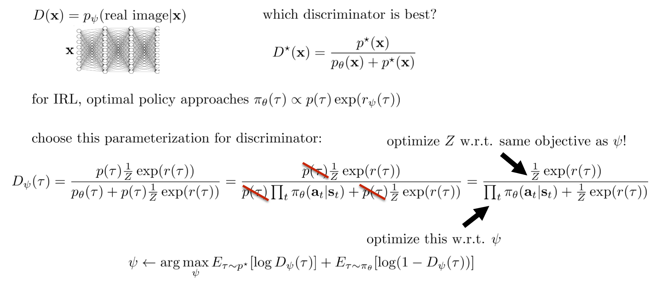

* Importance sampling weights are not needed anymore, subsumed into Z

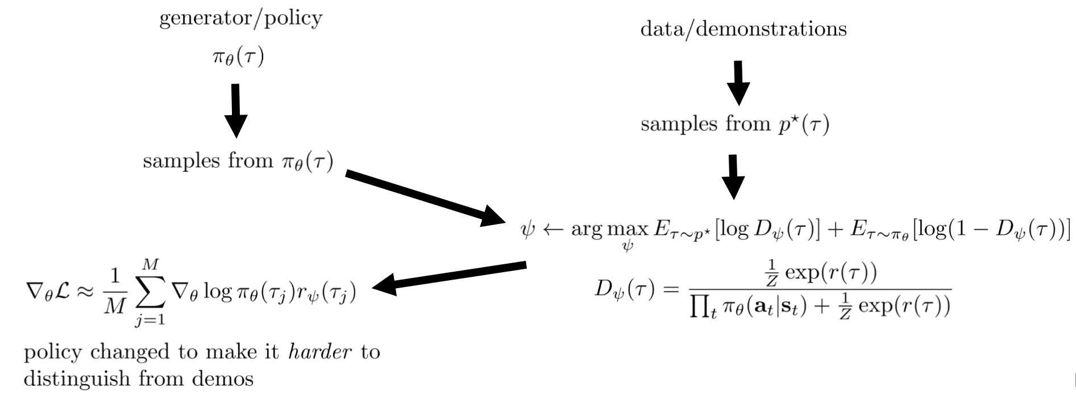

* One application of this: decoupling goals from dynamics to enable better transfer, i.e., reproduce behavior under *different* conditions
* See Fu et al. Learning Robust Rewards with Adversarial Inverse Reinforcement Learning
* IRL as adversarial optimization

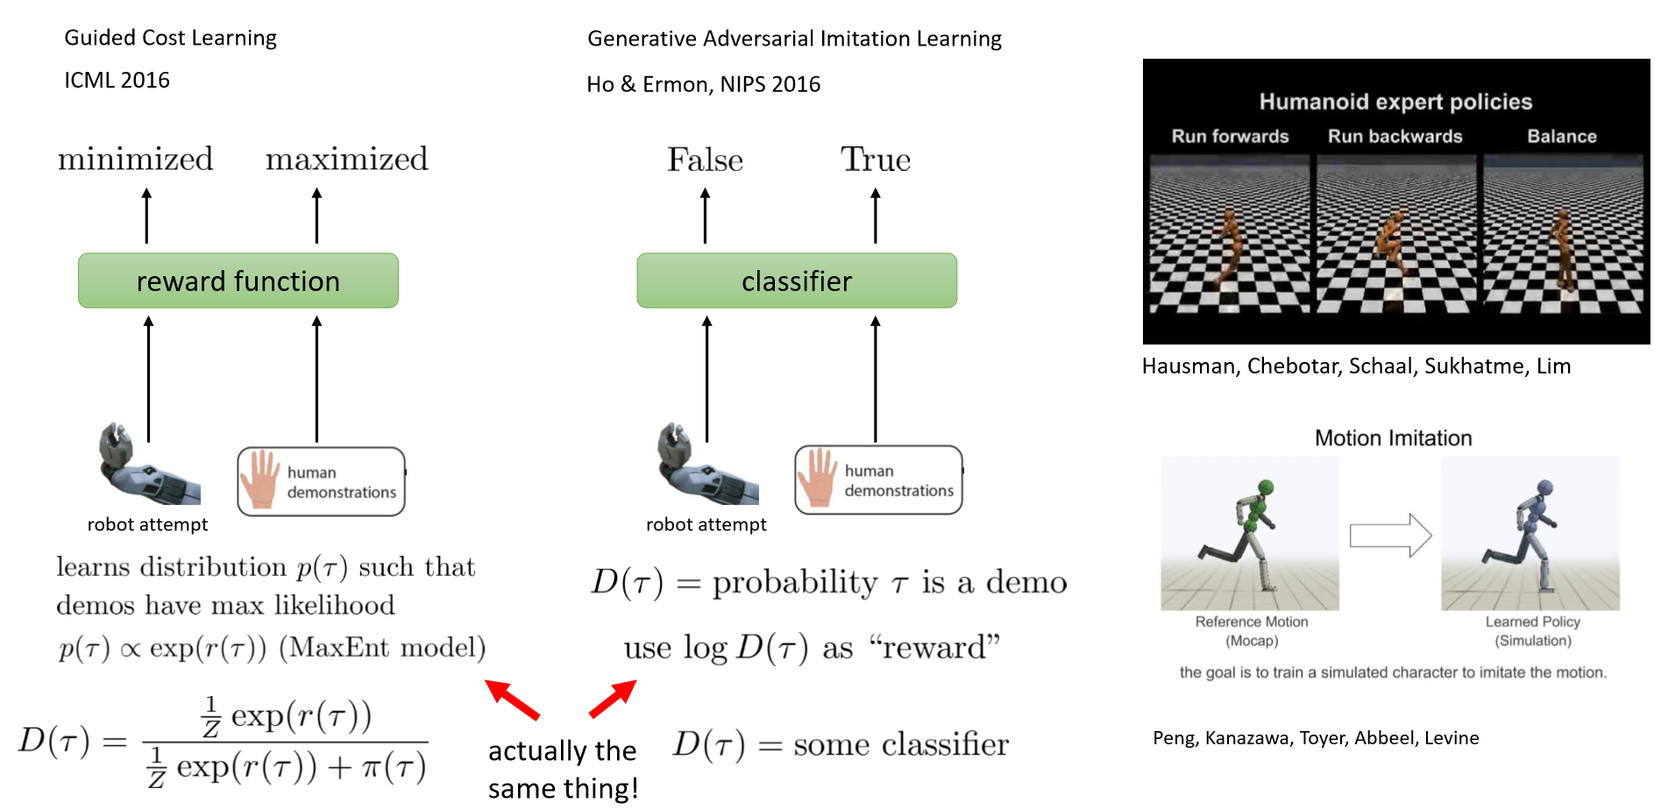

* Review
  + IRL: infer unknown reward from expert demonstrations
  + MaxEnt IRL: infer reward by learning under the control-as-inference framework
  + MaxEnt IRL with dynamic programming: simple and efficient, but requires small state space and known dynamics
  + Sampling-based MaxEnt IRL: generate samples to estimate the partition function
    - Guided cost learning algorithm
    - Connection to generative adversarial networks
    - Generative adversarial imitation learning
* Suggested readings
  + Classic papers
    - Abbeel & Ng ICML ’04. Apprenticeship Learning via Inverse Reinforcement Learning. [Good introduction to inverse reinforcement learning]
    - Ziebart et al. AAAI ’08. Maximum Entropy Inverse Reinforcement Learning. [Introduction to probabilistic method for inverse reinforcement learning]
  + Modern papers
    - Finn et al. ICML ’16. Guided Cost Learning. [Sampling based method for MaxEnt IRL that handles unknown dynamics and deep reward functions]
    - Wulfmeier et al. arXiv ’16. Deep Maximum Entropy Inverse Reinforcement Learning. [MaxEnt inverse RL using deep reward functions]
    - Ho & Ermon NIPS ’16. Generative Adversarial Imitation Learning. [Inverse RL method using generative adversarial networks]
    - Fu, Luo, Levine ICLR ‘18. Learning Robust Rewards with Adversarial Inverse Reinforcement Learning

**Exploration 1 (Week 17)**

* Topics
  + What is exploration
  + Optimism-based exploration
  + Posterior matching exploration
  + Information-theoretic exploration

**Exploration 2 (Week 18)**

* Topics
  + Classes of exploration methods in deep RL
  + Transfer learning

**Transfer and Multi-Task Learning (Week 19)**

* Topics
  + How can we frame transfer learning problems?
  + “Forward” transfer: train on one task, transfer to a new task
  + Multi-task transfer: train on many tasks, transfer to a new task
  + Multi-task meta-learning: learn to learn from many tasks

**Meta Reinforcement Learning (Week 20)**

* Topics
  + Meta-RL Problem Formulation & Examples
  + Method Classes: Recurrent Models, Gradient-Based Models
  + Challenges & Latest Developments